- CHAPTER OBJECTIVES
- Understand the importance of databases in Internet Web applications and mobile apps
- Understand the nature and characteristics of databases
- Understand the potential problems with lists
- Understand the reasons for using a database
- Understand how using related tables helps you avoid the problems of using lists
- Know the components of a database system
- Learn the elements of a database
- Learn the purpose of a database management system (DBMS)
- Understand the functions of a database application
- Introduce Web database applications
- Introduce data warehouses and business intelligence (BI) systems
- Introduce Big Data and cloud computing

- CHAPTER ERRATA
These are the known errors at this time. Any errors that are discovered in the future will be reported and corrected in the online DBC e09 Errata document, which will be available at http://www.pearsonhighered.com/kroenke.
- WORKING WITH MICROSOFT ACCESS
Solutions to the Access Workbench exercises may be found in Solutions to all Sections: Working with Microsoft Access, which is a separate document within the Instructor’s Manual.
- WARNING: CHANGES IN GRAPHICAL USER INTERFACES
You and your students need to be aware that changes in graphical user interface (GUI) designs can occur without warning, and therefore you may see slightly different user interface colors, icons, text, and item placement than shown in the figures in this book.
Until recently, changes to GUI designs only occurred when a new major version of an application was released. For example, after Microsoft Office 2010 was released, we would not expect to see changes to the GUI for Microsoft Excel, Microsoft Access, Microsoft Word, Microsoft PowerPoint, and other associated Microsoft Office applications until the next major version, Microsoft Office 2013, was released. The GUI was stable, and screenshots of the Microsoft Office products for books using Office 2010 would be accurate.
Now, however, we have entered an era of continuously updating revisions within major versions. The next product update, automatically scheduled and installed on your computer, may, without warning, change the GUI. While we have seen this happen with MySQL, and particularly with the MySQL Workbench, we are now seeing it happen with Microsoft Office 365 and Microsoft Office 2019 (which is a standardized subset of Office 365).
First, the Microsoft Office application icons have changed. When we began working on Database Concepts 9th edition, the icons appeared on the Taskbar as shown in Figure 1. When we started working on the online extensions, the icons for Microsoft Excel, Microsoft Word, and Microsoft PowerPoint had been revised, and now appeared as shown in Figure 2. While we were working on material for the Instructor’s Manual, the icon for Microsoft Access was revised and the Taskbar icons now appear as shown in Figure 3.

Figure 1 – Microsoft Office Taskbar Icons – Initial Set of Icons
Figure 2 – Microsoft Office Taskbar Icons – First Revised Set of Icons
Figure 3 – Microsoft Office Taskbar Icons – Set of Icons with Revised Microsoft Access Icon

These changes where not consistent across all systems! They occurred on one of our computers that was running Microsoft Office 2019 applications, while they did not happen on another computer that was running the Microsoft Office 365 version of the applications.
Second, the Start screen has been changed, again without warning. So far, this change has been applied to Microsoft Excel, Microsoft Word, and Microsoft PowerPoint, but not for Microsoft Access. Figure 4 shows the Start screen for Microsoft Access, while Figure 5 shows the new Start screen for Microsoft Excel.
Note the new Start screen style used for Microsoft Excel—Microsoft Word and Microsoft PowerPoint now use similar Start screens. We expect Microsoft Access will be updated sometime in the near future.
Finally, the design of the command tabs on the Ribbon in the Microsoft Office Fluent User Interface has changed. This is illustrated by contrasting Figure 6, which shows the Ribbon as it appears in the screen shots in the figures in Database Concepts 9th edition, and Figure 7, which shows the new changes to the Ribbon. Originally, the active command tab for Microsoft Access was a light grey with Red lettering, while the inactive tabs were red with white lettering. In the new design, the command tabs seem to be merged into a command bar with the active command (or command tab) underlined in red. Similar changes have been made in Microsoft Excel, Microsoft Word, and Microsoft PowerPoint.
Further, the Ribbon icons and text in most of the Office programs have been revised, with Microsoft Access apparently still awaiting updates.
Note that these changes do not affect the basic functionality of the Office programs. Except for creating new files and opening existing files from the new Start screens, the steps to use Microsoft Access and Microsoft Excel described in Database Concepts 9th edition are still the same!
However, you and your students need to be aware that what you see in Microsoft Access and Microsoft Excel will differ somewhat from what we captured in the screen shots used in this book. And you should now expect future changes in the Microsoft Office GUI, and in the GUIs for other products (MySQL Workbench is an example), to occur without warning. It is simply a consequence of the new “constant update” system of delivering software.
We recommend that you cover this topic with your students!
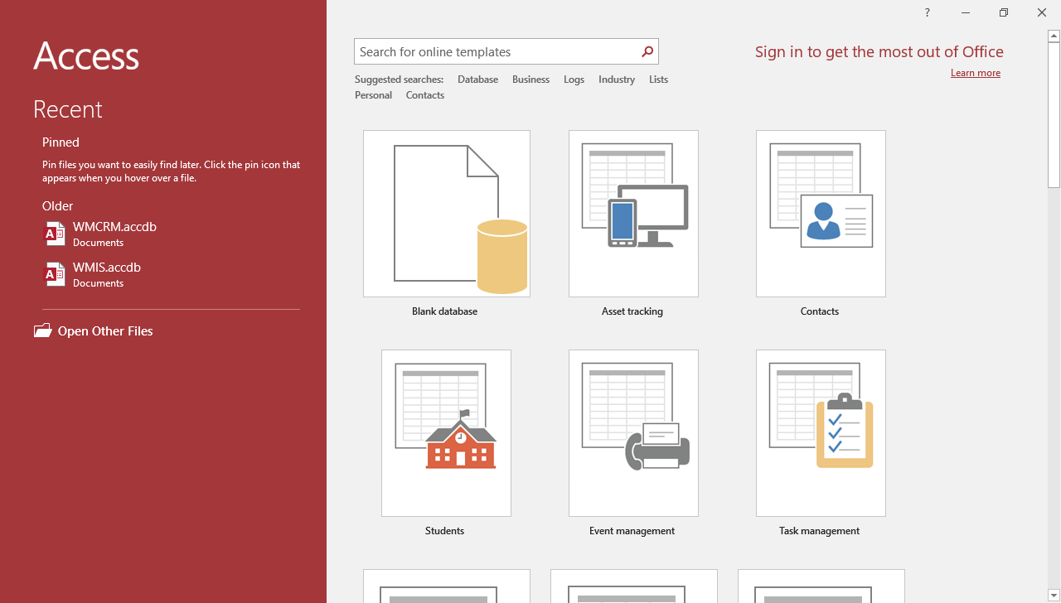
Figure 4 – Microsoft Access 2019 Start Screen

