**Chapter 2**

**Supply and Demand**

1.1 To find demand as a function of p, plug in the typical values for pb, pc, and Y and simplify:

Q=276-20p.

1.2 The demand curve for pork is *Q* 20 171 *p* 20*pb* 3*pc* 2*Y*, where quantity is measured in millionsof kg per year and income is measured in thousands of dollars per year. Holding other variables constantwe find: Δ*Q* 2Δ*Y*. That is, a $1000 increase in income (*Y* 1) causes the quantity demanded to increase by 2 million kg per year, and a $100 increase in income (*Y* 0.10) causes the quantity demanded to increase by one-tenth as much, or 0.2 million kg per year.

1.3 The demand curve for pork in Canada is

*Q* 20 171 *p* + 20*pb* 3*pc* + 2*Y*.

We can write the following, assuming the only change is in the price of beef:

Δ*Q* 20Δ*Pb*

Δ*Q* (20)(1.2) 48.

Therefore, the quantity demanded for pork increases with increased beef prices (Δ*Q*/Δ*pb*) 0. This means that the demand for pork shifts to the right.

1.4 The inverse demand function is *p*  0.05 14.30 *Q*. We know that Δ*p* 0.05Δ*Q.* If Δ*Q* 2 (a reduction of 2 million kg of pork per year), Δ*p* 0.05 × Thus, a 10 cent per kg increase in price will result in a 2 million kg drop in demand.

1.5  = 0.01.An increase in *Y* shifts the demand curve to the right, from *D*1 to *D*2.

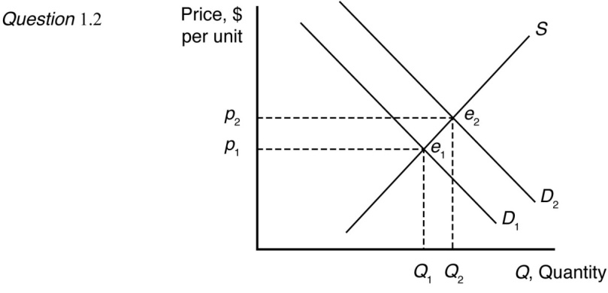

1.6 The total demand curve is the horizontal sum of the individual demand curves for food and feed:

Q=Qfood+Qfeed.

Since Qfeed=0 at prices above $27.56, for p > 27.56;

Q= 1,487 - 22.1p

and for p< 27.56

Q= 7,735 - 248.8p.

1.7 Q = Q1 + Q2 = (120 – p) + (60 – 1/2p) = 180 – 1.5p

1.8 The total demand function is *Q* = *Qs* + *Q*l = 15.6*p*-0.563 + 16*p*-0.296.

2.1 Supply: *Q* 40 178 *p* 60*ph*. Replacing *ph* with $3 per kg gives us a supply function *Q* 40178 *p* 60 × 40$3 *p*  2. That is, the slope of the supply curve does not change from Equation 2.7, but the whole supply curve shifts to the left.

2.2 The effect of a change in *pf* on *Q* is

 = –20*pf*

 = –20(1.10)

 = –22 units.

Thus, an increase in the price of fertilizer will shift the avocado supply curve to the left.

2.3 The world supply is: *Q* = *Qa* + *Qr* = (*a* + *c*) + (*b* + *e*)*p*.

2.4 Let’s say the U.S. domestic supply curve intersected the vertical axis at a price *p*’ (above The total supply curve would be the same as the foreign supply curve from a price of zero to *p*’, both before and after the quota is imposed. Above the price *p*’, the total supply curve would be the combined foreign and domestic quantity.

3.1 The statement “Talk is cheap because supply exceeds demand” makes sense if we interpret it to mean that the quantity supplied of talk exceeds the quantity demanded at a price of zero. Imagine a downward-sloping demand curve that hits the horizontal, quantity axis to the left of where the upward-sloping supply curve hits the axis. (The correct aphorism is “Talk is cheap until you hire a lawyer.”)

3.2

1. We know that the town consumes 9000 gallons per day at no cost, thus there is a point on the demand curve at *p* = 0, *q* = 9,000. By the “Law of Demand” the demand curve is weakly downward sloping (except in certain circumstances). Thus (since we assume there is no negative demand), a linear demand curve would be along the horizontal axis, where *p* = 0.
2. The supply curve is drawn along the horizontal axis from the point where *q* = 0 until *q* = 10,000. To the right of where *q* = 10,000, the supply curve is upward sloping.
3. Quantity supplied and demanded reach an equilibrium at any point under *q* = 10,000, where *p* = 0.

3.3 The supply curve is upward sloping and intersects the vertical price axis at $6. The demand curve is downward sloping and intersects the vertical price axis at $4. When all market participants are able to buy or sell as much as they want, we say that the market is in equilibrium: a situation in which no participant wants to change its behavior. Graphically, a market equilibrium occurs where supply equals demand. An equilibrium does not occur at a positive quantity because supply does not equal demand at any price.

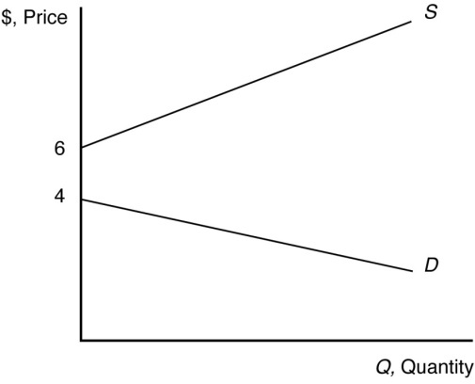

3.4 Demand: *Q* 20 171 *p* 20*pb* 3*pc* 2*Y*

Supply: *Q* 40 178 *p* 60*ph*

*p*\* 7 + 20[*pb* 3*pc* + 2*Y* + 60*ph*]/60

*Q*\* 7 + 20 40[178 *pb* + 3*pc* + 2*Y* + 60*ph*]/60

If *ph* 1.5, *pb*4, *pc* 3.33, and *Y* 12.5

20286 *p* 88 40*p*.

*p*\* $3.3

*Q*\* 220

3.5 In equilibrium, the quantity demanded, *Q* *a* *bp*, equals the quantity supplied,

*Q c* *ep*, so

*a* *bp* = *c* + *ep*.

By solving this equation for *p*, we find that the equilibrium price is:

*p* (*a* *c*)/(*b* + *e*).

By substituting this expression for *p* into either the demand curve or the supply curve, we find that the equilibrium quantity is:

*Q* (*ae* *bc*)/(*b* + *e*).

3.6 The demand for processed tomatoes is:



When *Pt* 110,



To find the equilibrium, we equate the right sides of the original logarithmic supply and demand functions and using algebra, we find:



We then set *pt* 110, solve for *p* $62.80/ton.

Or, we can find the supply function:



Equating the right side of the supply and demand functions, we find:



Substituting the price in either the supply or the demand function yields a quantity at equilibrium of about 11.9 million tons.

4.1 Outsourcing shifts the labor demand curve to the right because more Indian workers are demanded at each wage. The new market equilibrium is where the original supply curve intersects the new labor demand curve.

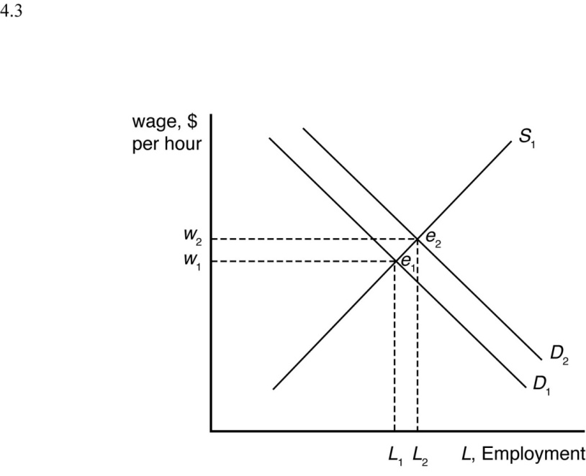

4.2 Suppose supply is initially *S*1, but it decreases by a small amount to *S*2 after the BP oil spill. When all market participants are able to buy or sell as much as they want, we say that the market is in equilibrium: a situation in which no participant wants to change its behavior. Graphically, a market equilibrium occurs where supply equals demand. The original market equilibrium is where the original demand curve intersects the original supply curve (*e*1). The new market equilibrium is where the original demand curve intersects the new supply curve (*e*2). When the supply curve shifts by a relatively small amount, the change in the equilibrium price is likely to be small.

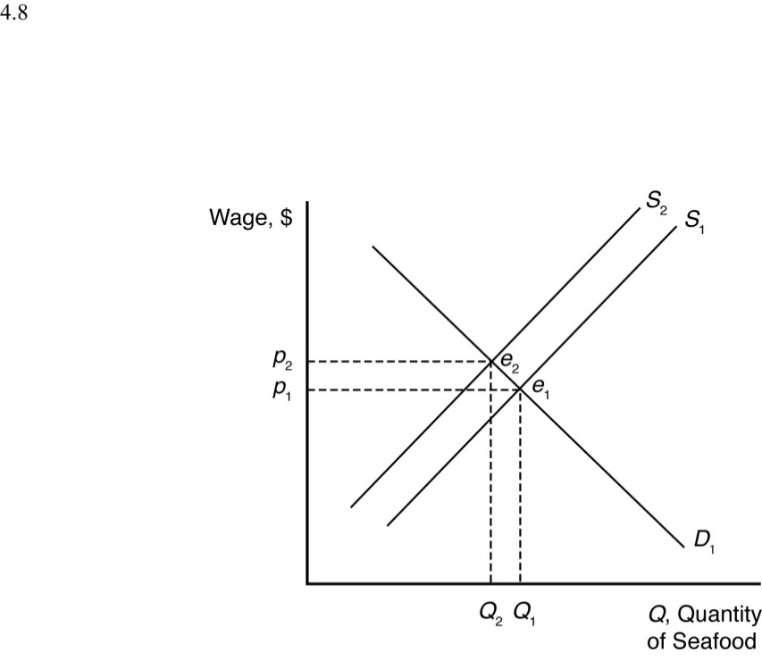

4.3 If the orange juice supply curve is the horizontal sum of the supply curves of U.S. and