Introductory Financial Accounting for Business, 1e (Edmonds)
Chapter 1 An Introduction to Accounting

Indicate how each event affects the elements of financial statements. Use the following letters to record your answer in the box shown below each element. You do not need to enter dollar amounts. (Note that "Not Affected" means that the event does not affect that element of the financial statements or the event causes an increase in that element that is offset by a decrease in the same element.)

Increase = I Decrease = D Not Affected = NA

1) Walker Co. issued common stock for $150,000 cash.

Assets | = | Liabilities | + | Common Stock | + | Retained Earnings

2) Nguyen Co. borrowed $50,000 cash from Metropolitan Bank.

Assets | = | Liabilities | + | Common Stock | + | Retained Earnings

3) Bell Co. provided consulting services for $20,000 cash.

Assets | = | Liabilities | + | Common Stock | + | Retained Earnings

4) Pierce Co. paid $40,000 cash to purchase land.

Assets | = | Liabilities | + | Common Stock | + | Retained Earnings

5) Perez Co. paid $220,000 cash for salaries expense.

Assets | = | Liabilities | + | Common Stock | + | Retained Earnings

6) Epstein Co. paid $20,000 in cash dividends to its owners.

Assets | = | Liabilities | + | Common Stock | + | Retained Earnings

7) North Co. issued a note to purchase a building.

Assets | = | Liabilities | + | Common Stock | + | Retained Earnings

8) Name the group that has the primary authority for establishing U.S. GAAP.

9) Who are the three distinct types of participants in the market for business resources? Briefly describe the role of each group of participants.

10) What is meant by the term "stakeholders"?

11) What is meant by the term "global GAAP"? How does it impact U.S. companies? What body is responsible for setting global standards?

12) Briefly distinguish between financial accounting and managerial accounting.

13) Explain some of the similarities and differences between not-for-profit organizations and other types of businesses.

14) What financial statement elements are reported on a balance sheet?

15) From what three sources does a business obtain its assets?

16) How does providing services for cash affect the accounting equation? Is it considered an asset source, asset use, or asset exchange transaction?

17) How does the payment of cash dividends to stockholders affect the accounting equation? Is it considered an asset source, asset use, or asset exchange transaction?

18) If total stockholder's equity is $150,000 and liabilities are $75,000, what are total assets?

19) What is meant by the term stockholders' equity?

20) Give three examples of asset use transactions.

21) What does a company's statement of cash flows tell you about the company?

22) If a corporation issues common stock for $50,000 cash, in which section of the statement of cash flows will this transaction be reported?

23) Which financial statement reports revenue and expenses?

24) Name and briefly describe each of the four financial statements.

25) Define the term "accounting period." How does this term relate to the "matching concept" as it pertains to the income statement?

26) Which of the following groups has the primary responsibility for establishing generally accepted accounting principles for business entities in the United States?
A) Securities and Exchange Commission
B) U.S. Congress
C) International Accounting Standards Board
D) Financial Accounting Standards Board

27) The Heritage Company is a manufacturer of office furniture. Which term best describes Heritage's role in society?
A) Conversion agent
B) Regulatory agency
C) Consumer
D) Resource owner

28) Which resource providers lend financial resources to a business with the expectation of repayment with interest?
A) Consumers
B) Creditors
C) Investors
D) Owners

29) Which type of accounting information is intended to satisfy the needs of external users of accounting information?
A) Cost accounting
B) Managerial accounting
C) Tax accounting
D) Financial accounting

30) Which of the following statements is false regarding managerial accounting information?
A) It is often used by investors.
B) It is more detailed than financial accounting information.
C) It can include nonfinancial information.
D) It focuses on divisional rather than overall profitability.

31) Financial accounting standards are known collectively as GAAP. What does that acronym stand for?
A) Generally Accepted Accounting Principles
B) Generally Applied Accounting Procedures
C) Governmentally Approved Accounting Practices
D) Generally Authorized Auditing Principles

32) International accounting standards are formulated by the IASB. What does that acronym stand for?
A) Internationally Accepted Standards Board
B) International Accounting Standards Board
C) International Accountability Standards Bureau
D) International Accounting and Sustainability Board

33) Which of the following is an example of revenue?
A) Cash received as a result of a bank loan
B) Cash received from investors from the sale of common stock
C) Cash received from customers at the time services were provided
D) Cash received from the sale of land for its original selling price

34) Which of the following is not an element of the financial statements?
A) Net income
B) Revenue
C) Assets
D) Cash

35) Algonquin Company reported assets of $50,000, liabilities of $22,000 and common stock of $15,000. Based on this information only, what is the amount of the company's retained earnings?
A) $7,000.
B) $57,000.
C) $13,000.
D) $87,000.

36) Stosch Company's balance sheet reported assets of $40,000, liabilities of $15,000 and common stock of $12,000 as of December 31, Year 1. Retained earnings on the December 31, Year 2 balance sheet is $18,000 and Stosch paid a $14,000 dividend during Year 2. What is the amount of net income for Year 2?
A) $17,000
B) $19,000
C) $13,000
D) $21,000

37) Hazeltine Company issued common stock for $200,000 cash. What happened as a result of this event?
A) Assets increased.
B) Equity increased.
C) Claims increased.
D) Assets, claims, and equity all increased.

38) Ballard Company reported assets of $500 and liabilities of $200. What amount will Ballard's report for stockholders' equity?
A) $300
B) $500
C) $700
D) Cannot be determined

39) A company's total assets increased during the period while its liabilities and common stock were unchanged. No dividends were declared or paid during the period. Which of the following would explain this situation?
A) Revenues were greater than expenses during the period.
B) Retained earnings were less than net income during the period.
C) No dividends were paid during the period.
D) The company must have purchased assets with cash during the period.

40) Li Company paid cash to purchase land. What happened as a result of this business event?
A) Total assets decreased.
B) Total assets were unaffected.
C) Total equity decreased.
D) Both assets and total equity decreased.

41) Turner Company reported assets of $20,000 (including cash of $9,000), liabilities of $8,000, common stock of $7,000, and retained earnings of $5,000. Based on this information, what can be concluded?
A) 25% of Turner's assets are the result of prior earnings.
B) $5,000 is the maximum dividend that can be paid to shareholders.
C) 40% of Turner's assets are the result of borrowing from creditors.
D) 25% of Turner's assets are from prior earnings, $5,000 is the maximum possible dividend, and 40% of assets are the result of borrowed resources.

42) At the time of liquidation, Fairchild Company reported assets of $200,000, liabilities of $120,000, common stock of $70,000 and retained earnings of $10,000. What is the maximum amount of Fairchild's assets that the shareholders are entitled to receive?
A) $200,000
B) $80,000
C) $90,000
D) $100,000

43) As of December 31, Year 2, Bristol Company had $100,000 of assets, $40,000 of liabilities and $25,000 of retained earnings. What percentage of Bristol's assets were obtained through investors?
A) 60%
B) 25%
C) 40%
D) 35%

44) On January 1, Year 2, Chavez Company had beginning balances as follows: total assets of $12,500, total liabilities of $4,500, and common stock of $3,000. During Year 2, Chavez paid dividends to its stockholders of $2,000. Given that retained earnings amounted to $6,000 at the end of Year 2, what was Chavez's net income for Year 2?
A) $3,000
B) $5,000
C) $7,000
D) $2,000

45) When a business provides services for cash, which elements of the accounting equation are affected?
A) Revenue and Expense
B) Cash and Revenue
C) Cash and Expense
D) Cash and Dividends

46) During Year 2, Millstone Company provided $6,500 of services for cash, paid cash dividends of $1,000 to owners, and paid $4,000 cash for expenses. Liabilities were unchanged. Which of the following statements accurately describes the effect of these events on the elements of the company's financial statements?
A) Assets increased by $6,500.
B) Assets increased by $1,500.
C) stockholders' equity increased by $2,500.
D) Assets increased by $5,500.

47) At the end of Year 2, retained earnings for the Baker Company was $3,500. Revenue earned by the company in Year 2 was $1,500, expenses paid during the period were $800, and dividends paid during the period were $500. Based on this information alone, what was the amount of retained earnings at the beginning of Year 2?
A) $3,300
B) $3,700
C) $2,800
D) $3,800

48) Which of the following is not an example of an asset use transaction?
A) Paying cash dividends
B) Paying cash expenses
C) Paying off the principal of a loan
D) Paying cash to purchase land

49) Borrowing cash from the bank is an example of which type of transaction?
A) Asset source
B) Claims exchange
C) Asset use
D) Asset exchange

50) Tandem Company borrowed $32,000 of cash from a local bank. Which of the following choices accurately reflects how this event affects the accounting equation?

 | Assets | = | Liabilities | + | Common  Stock | + | Retained  Earnings
A. | NA | = | 32,000 | + | NA | + | 32,000
B. | 32,000 | = | NA | + | 32,000 | + | NA
C. | 32,000 | = | NA | + | NA | + | 32,000
D. | 32,000 | = | 32,000 | + | NA | + | NA

A) Option A
B) Option B
C) Option C
D) Option D

51) Which of the following could describe the effects of an asset exchange transaction on a company's total assets, total liabilities and total equity?

 | Assets | = | Liab. | + | Equity
A. | NA | = | NA | + | NA
B. | + | = | NA | + | +
C. | − | = | NA | + | −
D. | NA | = | NA | + | + −

A) Option A
B) Option B
C) Option C
D) Option D

52) Which of the following describes the effects of an asset use transaction on the accounting equation?

 | Assets | = | Liab. | + | Equity
A. | + | = | + | + | NA
B. | − | = | NA | + | −
C. | + − | = | NA | + | NA
D. | NA | = | + | + | NA

A) Option A
B) Option B
C) Option C
D) Option D

53) Which of the following cash transactions would not affect total assets?
A) Borrowing cash from a bank
B) Issuing common stock for cash
C) Purchasing land for cash
D) Providing services for cash

54) Which of the following appears in the investing activities section of the statement of cash flows?
A) Cash inflow from interest revenue
B) Cash inflow from the issuance of common stock
C) Cash outflow for the payment of dividends
D) Cash outflow for the purchase of land

55) Jackson Company had a net increase in cash from operating activities of $10,000 and a net decrease in cash from financing activities of $2,000. If the beginning and ending cash balances for the company were $4,000 and $11,000, what was the net cash change from investing activities?
A) An outflow or decrease of $1,000
B) An inflow or increase of $2,000
C) An inflow or increase of $1,000
D) Zero

[The following information applies to the questions displayed below.]

The financial statements of Calloway Company prepared at the end of the current year contained the following elements and corresponding amounts: Assets = $50,000; Liabilities = ?; Common Stock = $15,000; Revenue = $22,000; Dividends = $1,500; Beginning Retained Earnings = $3,500; Ending Retained Earnings = $7,500.

56) Based on this information, what was the amount of expenses reported on Calloway's income statement for the current year?
A) $18,500
B) $13,000
C) $16,500
D) $10,000

57) What was the amount of total liabilities reported on the balance sheet as of the end of the current year?
A) $27,500
B) $31,500
C) $35,000
D) $42,500

58) Which of the following financial statements provides information about a company as of a specific point in time?
A) Income statement
B) Balance sheet
C) Statement of cash flows
D) Statement of changes in stockholders' equity

59) In which section of a statement of cash flows would the payment of cash dividends be reported?
A) Investing activities.
B) Operating activities.
C) Financing activities.
D) Dividends are not reported on the statement of cash flows.

60) Which financial statement matches asset increases from operating a business with asset decreases from operating the business?
A) Balance sheet
B) Statement of changes in equity
C) Income statement
D) Statement of cash flows

61) Chow Company earned $1,500 of cash revenue, paid $1,200 for cash expenses, and paid a $200 cash dividend to its owners. Which of the following statements is true?
A) The net cash inflow from operating activities was $100.
B) The net cash outflow for investing activities was $200.
C) The net cash inflow from operating activities was $300.
D) The net cash outflow for investing activities was $100.

62) Yi Company provided services to a customer for $5,500 cash. Based on this information alone, which of the following statements is true?
A) Total assets increased and total equity decreased.
B) Total assets were unchanged.
C) Liabilities decreased and net income increased.
D) Total assets increased and net income increased.

63) During Year 2, Chico Company earned $1,950 of cash revenue, paid $1,600 of cash expenses, and paid a $150 cash dividend to its owners. Based on this information alone, which of the following statements is not true?
A) Net income amounted to $350.
B) Total assets increased by $200.
C) Cash inflow from operating activities was $350.
D) Cash inflow from operating activities was $200.

64) Glavine Company repaid a bank loan with cash. The cash flow from this event should be reported as:
A) an outflow for investing activities on the Statement of Cash Flows
B) an outflow for financing activities on the Statement of Cash Flows
C) an inflow for investing activities on the Statement of Cash Flows
D) an inflow for operating activities on the Statement of Cash Flows

65) Retained earnings at the beginning and ending of the accounting period were $300 and $800, respectively. Revenues of $1,100 and dividends paid to stockholders of $200 were reported during the period. What was the amount of expenses reported for the period?
A) $500
B) $400
C) $900
D) $700

[The following information applies to the questions displayed below.]

Yowell Company began operations on January 1, Year 1. During Year 1, the company engaged in the following cash transactions:

1) issued stock for $40,000
2) borrowed $25,000 from its bank
3) provided consulting services for $39,000
4) paid back $15,000 of the bank loan
5) paid rent expense for $9,000
6) purchased equipment costing $12,000
7) paid $3,000 dividends to stockholders
8) paid employees' salaries for work completed during the year, $21,000

66) What is Yowell's net cash flow from operating activities?
A) Inflow of $6,000
B) Inflow of $9,000
C) Inflow of $18,000
D) Inflow of $30,000

67) What is Yowell's ending notes payable balance?
A) $0
B) $25,000
C) ($15,000)
D) $10,000

68) What is Yowell's net income?
A) $9,000
B) $30,000
C) $18,000
D) $6,000

[The following information applies to the questions displayed below.]

Packard Company engaged in the following transactions during Year 1, its first year of operations: (Assume all transactions are cash transactions.)

1) Acquired $950 cash from the issue of common stock.
2) Borrowed $420 from a bank.
3) Earned $650 of revenues.
4) Paid expenses of $250.
5) Paid a $50 dividend.

During Year 2, Packard engaged in the following transactions: (Assume all transactions are cash transactions.)

1) Issued an additional $325 of common stock.
2) Repaid $220 of its debt to the bank.
3) Earned revenues of $750.
4) Incurred expenses of $360.
5) Paid dividends of $100.

69) What is Packard Company's net cash flow from financing activities for Year 2?
A) $220 outflow
B) $320 outflow
C) $5 inflow
D) $225 inflow

70) The amount of total liabilities on Packard's Year 1 balance sheet is
A) $200
B) $340
C) $420
D) $670

71) What is the amount of total stockholders' equity that will be reported on Packard's balance sheet at the end of Year 1?
A) $1,350
B) $900
C) $250
D) $1,300

72) The amount of assets on Packard's Year 2 balance sheet is
A) $2,115.
B) $440.
C) $2,215.
D) $395.

73) What is the net cash inflow from operating activities that will be reported on Packard's statement of cash flows for Year 1?
A) $400
B) $650
C) $350
D) $820

74) Which of the following would be reported in the cash flow from financing activities section of a statement of cash flows?
A) Paid cash for dividends
B) Received cash for common stock
C) Sold land for cash
D) Paying cash for dividends and receiving cash from common stock

75) Santa Fe Company was started on January 1, Year 1, when it acquired $9,000 cash by issuing common stock. During Year 1, the company earned cash revenues of $4,500, paid cash expenses of $3,750, and paid a cash dividend of $250. Which of the following is true based on this information?
A) The December 31, Year 1 balance sheet would show total equity of $8,750.
B) The Year 1 income statement would show net income of $500.
C) The Year 1 statement of cash flows would show net cash inflow from operating activities of $4,500.
D) The Year 1 statement of cash flows would show a net cash inflow from financing activities of $8,750.

76) Robertson Company paid $1,850 cash for rent expense. What happened as a result of this business event?
A) Total equity decreased.
B) Liabilities decreased.
C) The net cash flow from operating activities decreased.
D) Both total equity and net cash flow for operating activities decreased.

77) Mayberry Company paid $30,000 cash to purchase land. What happened as a result of this business event?
A) Total equity was not affected.
B) The net cash flow from investing activities decreased.
C) Total assets were not affected.
D) Total assets and total equity were not affected, and net cash flow from investing activities decreased.

[The following information applies to the questions displayed below.]

Lexington Company engaged in the following transactions during Year 1, its first year in operation: (Assume all transactions are cash transactions.)

1) Acquired $6,000 cash from issuing common stock.
2) Borrowed $4,400 from a bank.
3) Earned $6,200 of revenues.
4) Incurred $4,800 in expenses.
5) Paid dividends of $800.

Lexington Company engaged in the following transactions during Year 2: (Assume all transactions are cash transactions.)

1) Acquired an additional $1,000 cash from the issue of common stock.
2) Repaid $2,600 of its debt to the bank.
3) Earned revenues, $9,000.
4) Incurred expenses of $5,500.
5) Paid dividends of $1,280.

78) What was the net cash flow from financing activities reported on Lexington's statement of cash flows for Year 2?
A) $2,880 outflow
B) $2,880 inflow
C) $1,000 outflow
D) $1,000 inflow

79) What is the amount of total assets that will be reported on Lexington's balance sheet at the end of Year 1?
A) $11,000
B) $12,000
C) $1,600
D) $7,600

80) What was the amount of retained earnings that will be reported on Lexington's balance sheet at the end of Year 1?
A) $6,200
B) $5,400
C) $1,400
D) $600

81) What was the amount of liabilities on Lexington's balance sheet at the end of Year 2?
A) $1,000.
B) $1,800.
C) ($2,600).
D) $480.

82) As of December 31, Year 1, Mason Company had $500 cash. During Year 2, Mason earned $1,200 of cash revenue and paid $800 of cash expenses. What is the amount of cash that will be reported on the balance sheet at the end of Year 2?
A) $900
B) $400
C) $1,700
D) $2,500

83) Expenses are reported on which of the following financial statement(s)?
A) Income statement
B) Balance sheet
C) Statement of changes in stockholders' equity
D) Income statement and statement of changes in stockholders' equity

84) Dividends paid by a company are reported on which of the following financial statement(s)?
A) Income statement
B) Statement of changes in stockholders' equity
C) Statement of cash flows
D) Statement of changes in stockholders' equity and statement of cash flows

85) Liabilities are reported on which of the following financial statement(s)?
A) Income statement
B) Balance sheet
C) Statement of cash flows
D) Statement of changes in stockholders' equity

86) Frank Company earned $15,000 of cash revenue. Which of the following accurately reflects how this event affects the company's accounting equation?

 | Assets | = | Liabilities | + | Common  Stock | + | Retained  Earnings
A. | 15,000 | = | NA | + | 15,000 | + | NA
B. | 15,000 | = | NA | + | 7,500 | + | 7,500
C. | 15,000 | = | NA | + | NA | + | 15,000
D. | 15,000 | = | 15,000 | + | NA | + | NA

A) Option A
B) Option B
C) Option C
D) Option D

87) Jackson Company paid $500 cash for salary expenses. Which of the following accurately reflects how this event affects the company's accounting equation?

 | Assets | = | Liab. | + | Equity
A. | 500 | = | 500 | + | NA
B. | (500) | = | NA | + | (500)
C. | (500) | = | (500) | + | NA
D. | (500) | = | NA | + | 500

A) Option A
B) Option B
C) Option C
D) Option D

88) Perez Company paid a $300 cash dividend. Which of the following accurately reflects how this event affects the company's financial statements?

 | Assets | = | Liabilities | + | Common  Stock | + | Retained  Earnings
A. | 300 | = | 300 | + | NA | + | NA
B. | (300) | = | NA | + | (300) | + | NA
C. | (300) | = | NA | + | NA | + | (300)
D. | 300 | = | NA | + | NA | + | 300

A) Option A
B) Option B
C) Option C
D) Option D

89) Garrison Company acquired $23,000 by issuing common stock. Which of the following accurately reflects how this event affects the company's accounting equation?

 | Assets | = | Liabilities | + | Common  Stock | + | Retained  Earnings
A. | 23,000 | = | NA | + | 23,000 | + | NA
B. | NA | = | 23,000 | + | (23,000) | + | NA
C. | NA | = | NA | + | 23,000 | + | (23,000)
D. | 23,000 | = | NA | + | NA | + | 23,000

A) Option A
B) Option B
C) Option C
D) Option D

90) Which of the following could represent the effects of an asset source transaction on the accounting equation?

 | Assets | = | Liabilities | + | Stockholders'  Equity
A. | + | = | + | + | NA
B. | − | = | NA | + | −
C. | +− | = | NA | + | NA
D. | NA | = | + | + | −

A) Option A
B) Option B
C) Option C
D) Option D

91) Reynolds Company experienced an accounting event that affected its financial statements as indicated below:

Assets | = | Liabilities | + | Stockholders'  Equity
+ | = | NA | + | +

Which of the following accounting events could have caused these effects on Reynolds' accounting equation?
A) Paid a cash dividend.
B) Earned cash revenue.
C) Borrowed money from a bank.
D) The information provided does not represent a completed event.

92) Chico Company experienced an accounting event that affected its accounting equation as indicated below:

Assets | = | Liabilities | + | Common  Stock | + | Retained  Earnings
+ | = | NA | + | + | + | NA

Which of the following accounting events could have caused these effects on Chico's statements?
A) Issued common stock.
B) Paid cash expenses.
C) Borrowed money from a bank.
D) Paid a cash dividend.

93) Delta Company experienced an accounting event that affected its financial statements as indicated below:

Assets | = | Liabilities | + | Common  Stock | + | Retained  Earnings
- | = | NA | + | NA | + | -

Which of the following accounting events could have caused these effects on Delta's statements?
A) Purchased land for cash.
B) Incurred a cash expense.
C) Borrowed money from a bank.
D) Earned cash revenue.

94) Which of the following would not describe the effects of an asset source transaction on the accounting equation?

 | Assets | = | Liabilities | + | Common  Stock | + | Retained  Earnings
A. | + | = | + | + | NA | + | NA
B. | + | = | NA | + | NA | + | +
C. | + | = | NA | + | + | + | NA
D. | +− | = | NA | + | NA | + | NA

A) Option A
B) Option B
C) Option C
D) Option D

95) The statement of changes in stockholders' equity presents
A) an explanation of the changes in the beginning and ending balances of stockholders' equity.
B) a comparison of the benefits and the sacrifices a company experiences from its operations.
C) information in three categories including operating, investing, and financing activities.
D) a list of a company's assets and the sources of those assets.

96) Which of the financial statements are required by the Generally Accepted Accounting Principles (GAAP)?
A) Income Statement
B) Statement of Changes in stockholders' equity
C) Statement of Cash Flows
D) Balance Sheet
E) All of these financial statements are required by GAAP

97) What is the process of dividing up assets and allocating them to resource providers (creditors and investors)?
A) Equity distribution
B) Stock repayment
C) Liquidation
D) Utilization

98) What does negative retained earnings indicate?
A) The company has lost some or all of the owners' investment
B) The company experienced a large cash outflow during the year
C) The company's liabilities are greater than its assets
D) The company's common stock is negative

99) A net loss occurs when
A) expenses are greater than revenues
B) liabilities are greater than assets
C) cash inflow is less than cash outflow
D) the ending cash balance is lower than the beginning cash balance

100) Indicate whether each of the following statements about markets is true or false.

________ a) Financial resources can be provided to a business by conversion agents.
________ b) Resource owners are the businesses that transform resources into products that satisfy consumer desires.
________ c) Labor resources include both the physical and intellectual labor of a business's employees.
________ d) Conversion agents purchase their resources from resource owners.
________ e) Consumers are the main providers of resources in any market.

101) Indicate whether each of the following statements about accounting information is true or false.

________ a) Financial accounting is primarily intended to satisfy the information needs of internal stakeholders.
________ b) Managerial accounting information includes financial and nonfinancial information.
________ c) The accounting information intended to satisfy the needs of a company's employees is managerial accounting information.
________ d) GAAP requires that companies adhere to financial accounting standards.
________ e) Managerial accounting information is usually less detailed than financial accounting information.

102) Indicate whether each of the following statements about liabilities is true or false.

________ a) Expenses are reported on the balance sheet.
________ b) The acquisition of a bank loan increases both assets and liabilities.
________ c) The accounting equation requires that liabilities be equal to equity.
________ d) The amount of a company's liabilities is equal to the difference between its assets and its equity.
________ e) Liabilities are reported on the statement of cash flows of a business.

103) Indicate whether each of the following statements about retained earnings is true or false.

________ a) A dividend paid to stockholders decreases retained earnings.
________ b) Issuing common stock for cash increases retained earnings.
________ c) The amount of net income for a period must equal retained earnings.
________ d) The purchase of a truck decreases retained earnings.
________ e) Net income increases retained earnings.

104) Indicate whether each of the following statements about the types of transactions is true or false.

________ a) An asset source transaction increases total assets and increases claims to assets.
________ b) The issuance of stock to owners for cash would be an example of an asset exchange transaction.
________ c) Purchasing equipment for cash is an example of an asset use transaction.
________ d) Paying a dividend to stockholders is an example of an asset use transaction.
________ e) Making a payment on a bank loan is an example of an asset exchange transaction.

105) Indicate whether each of the following statements about financial statements is true or false.

________ a) A cash dividend paid to stockholders is reported in the investing activities section of the statement of cash flows.
________ b) A cash dividend paid to stockholders is reported on the statement of changes in stockholders' equity.
________ c) A cash dividend paid to stockholders is reported on the income statement.
________ d) The balance sheet reports the ending balances of permanent accounts as of the last day of the accounting period.
________ e) Changes in retained earnings during the accounting period are reported on the income statement.

106) Indicate whether each of the following statements about equity is true or false.

________ a) Expenses decrease retained earnings.
________ b) stockholders' equity and liabilities can be viewed either as sources of assets or claims to assets of the business.
________ c) Retained earnings is increased by loans received from a bank.
________ d) Dividends paid to stockholders decrease common stock.
________ e) Generally, assets are reported at the actual price paid for them when purchased regardless of subsequent changes in market value.

107) In a market, creditors are resource providers.

108) In a market, a company that manufactures cars would be referred to as a conversion agent.

109) The value created by a business is created by its assets.

110) The stockholders of a business have a priority claim to its assets in the event of liquidation.

111) The types of resources needed by a business are financial, physical, and labor resources.

112) Financial accounting information is usually less detailed than managerial accounting information.

113) The Financial Accounting Standards Board is a privately funded organization with authority for establishing accounting standards for businesses in the US.

114) A business and the person who owns the business are separate reporting entities.

115) The information reported in financial statements is organized into ten categories known as accounts.

116) Liabilities are obligations of a business to relinquish assets, provide services, or accept other obligations.

117) Liabilities are not a source of assets for a business.

118) Retained earnings reduces a company's commitment to use its assets for the benefit of its stockholders.

119) The historical cost concept requires that most assets be recorded at the amount paid for them, regardless of increases in market value.

120) An asset source transaction increases a business's assets and the claims to assets.

121) Borrowing money from the bank is an example of an asset source transaction.

122) An asset use transaction does not affect the total amount of claims to a company's assets.

123) The four financial statements prepared by a business bear no relationship to each other.

124) The dividends a business pays to its owners appear on the income statement.

125) Jessup Company was founded in Year 1. It acquired $45,000 cash by issuing stock to investors and an additional $15,000 cash by borrowing from creditors. During Year 1 it received $25,000 cash revenues and paid $32,000 in cash expenses. The company then went out of business.

Required:
a) Explain the term, "business liquidation."
b) What amount of cash should Jessup Company have had on hand immediately before going out of business?
c) What amount of cash will Jessup's creditors receive?
d) What amount of cash will Jessup's stockholders receive?

126) Bates Company entered into the following transactions during its first year in business. Assume that all transactions involve the receipt or payment of cash.
1) Issued common stock to investors for $25,000 cash.
2) Borrowed $18,000 from the local bank.
3) Provided services to customers for $28,000.
4) Paid expenses amounting to $21,400.
5) Purchased a plot of land costing $22,000.
6) Paid a dividend of $15,000 to its stockholders.
7) Repaid $12,000 of the loan listed in item 2.

Required:
(a) Fill in the three column headings of the accounting equation in the first row of the table shown below.
(b) Show the effects of the above transactions on the accounting equation.

(a) ________ = ________ + ________
(b)
Event No.
1)
2)
3)
4)
5)
6)
7)

127) Each of the following requirements is independent of the others.
a) Valdez Corporation has liabilities of $95,000 and equity of $115,000. What is the amount of Valdez's assets? ________
b) Global Company has assets of $320,000 and liabilities of $95,000. What is the amount of Global's equity? ________
c) Brown Company has assets of $90,000 and liabilities of $25,000. What is the amount of Brown's claims? ________

128) The following business events occurred for Ringgold Company during Year 1, its first year in operation:
1. Issued stock to investors for $45,000 cash
2. Borrowed $25,000 cash from the local bank
3. Provided services to its customers and received $32,000 cash
4. Paid expenses of $28,000
5. Paid $22,000 cash for land
6. Paid dividend of $12,000 to stockholders
7. Repaid $10,000 of the loan listed in item 2

Required:
a) Show the effects of the above transactions on the accounting equation, below. Include dollar amounts of increases and decreases. Enter "NA" for elements of the accounting equation that are not affected by the transaction. If one element of the accounting equation is affected by an increase and also by a decrease, enter each part on a separate line. (The effects of the first transaction is shown below.)
b) After entering all the events, calculate the total amounts of assets, liabilities, and equity at the end of the year.

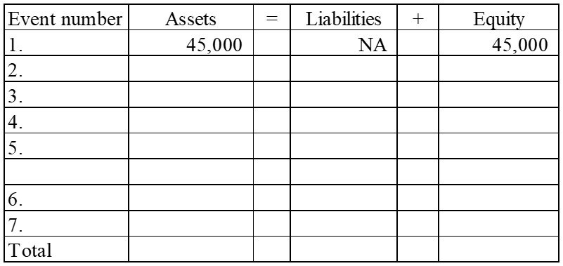

129) Ramirez Company experienced the following events during Year 1:
1. Acquired $50,000 cash by issuing common stock
2. Borrowed $25,000 cash from a creditor
3. Provided services to customers for $38,000 cash
4. Paid $32,000 cash for operating expenses
5. Paid a cash dividend of $2,500 to stockholders
6. Purchased land with cash, $30,000

Required:
a) Show how each of these events affects the accounting equation. Enter "NA" for elements of the accounting equation that are not affected by the transaction. If one element of the accounting equation is affected by an increase and also by a decrease, enter each part on a separate line. (The effects of the first event are shown below.)
b) Calculate the total amount of assets, liabilities, common stock, and retained earnings at the end of the period.

 |  |  |  |  | Stockholders' Equity
Event number | Assets | = | Liabilities | + | Common Stock | + | Retained Earnings
1. | 50,000 |  | NA |  | 50,000 |  | NA
2.
3.
4.
5.
6.
Total

130) At the beginning of Year 2, the accounting records of Grace Company included the accounts and balances shown on the first row of the table below. During Year 2, the following transactions occurred:
1. Received $95,000 cash for providing services to customers
2. Paid salaries expense, $50,000
3. Purchased land for $12,000 cash
4. Paid $4,000 on note payable
5. Paid operating expenses, $22,000
6. Paid cash dividend, $2,500

Required:
a) Record the transactions in the appropriate accounts. Record the amounts of revenue, expense, and dividends in the retained earnings column. Enter 0 for items not affected. Provide appropriate titles for these accounts in the last column of the table. (The effects of the first event are shown below.)

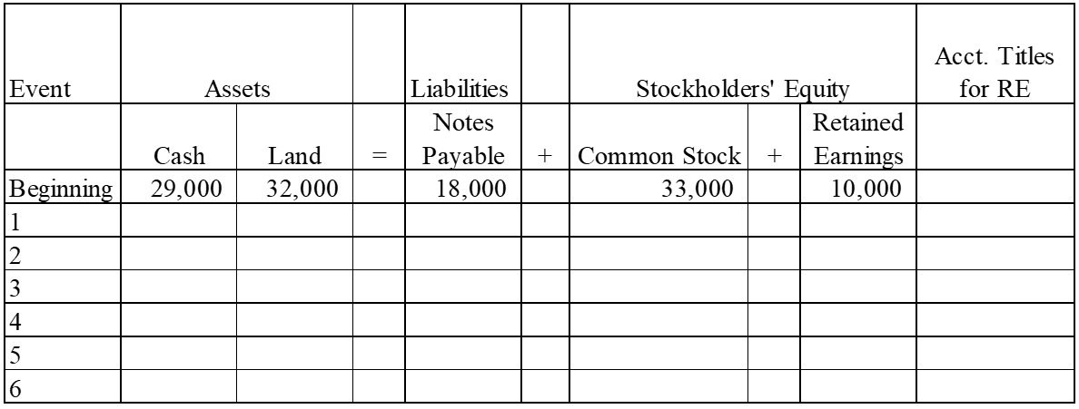
b) What is the amount of total assets as of December 31, Year 2?
c) What is the amount of total stockholders' equity as of December 31, Year 2?

131) Montgomery Company experienced the following events during Year 1 (all were cash events):
1. Issued a note
2. Paid operating expenses
3. Issued common stock
4. Provided services to customers
5. Repaid part of the note in event 1
6. Paid dividends to stockholders

Required:
Indicate how each of these events affects the accounting equation by writing the letter "I" for increase, the letter "D" for decrease, and "NA" for no effect under each of the components of the accounting equation. Use only one item of entry in each column. (The effects of the first event are shown below.)

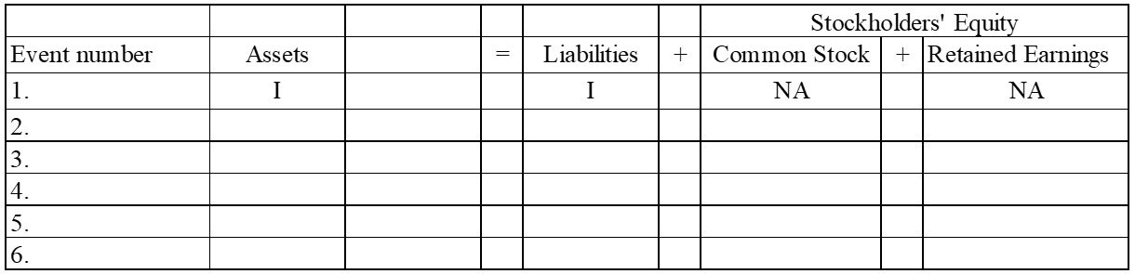

132) Indicate how each of the following transactions affects assets by entering "+" for increase, "−" for decrease, or "NA" if total assets are not affected. Enter only one item for each answer.
________ 1) Issued stock to investors.
________ 2) Borrowed cash from the bank.
________ 3) Provided services for cash.
________ 4) Paid operating expenses.
________ 5) Purchased land for cash.
________ 6) Paid cash dividend to the stockholders.
________ 7) Repaid the bank loan.

133) Classify each of the following events as an asset source (designate as "AS"), asset use (designate as "AU"), asset exchange (designate as "AX"), or not an asset source (designate as "NA").
________ 1) Borrowed cash from the bank
________ 2) Issued stock for cash
________ 3) Invested cash in the common stock of another company
________ 4) Performed services and collected cash
________ 5) P aid cash for operating expense
________ 6) Purchased equipment for cash
________ 7) Paid dividends to stockholders
________ 8) Repaid the bank loan with cash

134) Grimes Corporation reports the following cash transactions for the year ending December 31, Year 1, its first year of operation:
1) Issued common stock for $35,000
2) Borrowed $25,000 from a local bank
3) Purchased land for $40,000
4) Provided services to clients for $38,000
5) Paid operating expenses of $30,500
6) Paid $2,000 cash dividends to stockholders
Required:
a) What are the total assets for Grimes Corporation at December 31, Year 1?
b) Prepare an income statement for Year 1.

135) Young Company reported the following balance sheet for the end of Year 1:

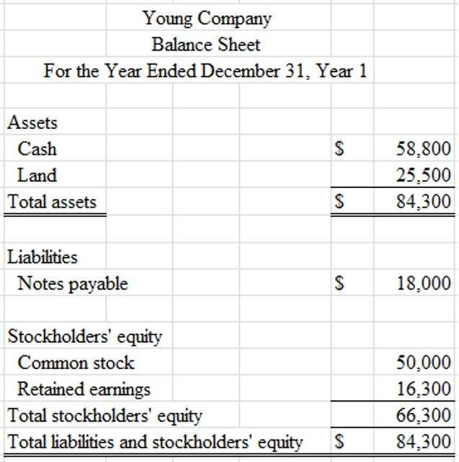
During Year 2, Young reported the following transactions:
• Repaid $9,000 to a local bank on a note payable
• Provided services to clients for $27,400 cash
• Paid operating expenses of $20,200
• Paid $4,500 cash dividends to stockholders
Required:
Prepare Young Company's balance sheet as of December 31, Year 2.

136) Use the following information to prepare an income statement for Penelope Company for the period ending December 31, Year 1. All transactions were for cash.
A) Received revenue from services provided to customers, $30,500.
B) Paid $19,000 cash for land.
C) Issued $16,000 of common stock.
D) Paid dividends to stockholders, $3,000.
E) Paid operating expenses, $25,400.

137) The following events are for Holiday Travel Services for Year 1, the first year of operations. Assume that all transactions involve the receipt or payment of cash.
1) The business acquired $50,000 from stock issued to owners.
2) Creditors loaned the company $27,500.
3) The company provided services to its customers and received $75,400.
4) The company paid expenses amounting to $63,250.
5) The company purchased land for $25,000.
6) The company paid a dividend of $5,500 to its owners.
Required:
a) Show the effects of the above transactions on the accounting equation. (Start by using appropriate element and account headings). For those events that affect retained earnings, indicate in a separate column the appropriate temporary account. Enter a "0" if a transaction does not affect a given account.

 |  |  |  | = |  | +
Event No. |  | + |  | = |  | + |  | + |  | Other Account Titles
1
2
3
4
5
6
Totals

b) Prepare an income statement and balance sheet for and as of the end of Year 1.

138) The following transactions apply to Wilson Fitness Center for Year 1.
1) Started the business by issuing $48,000 of common stock for cash.
2) Provided services to clients and received $65,500 cash.
3) Borrowed $10,500 from the bank.
4) Paid $8,500 for rent of equipment.
5) Purchased land for $15,000.
5) Paid $46,600 of salary expense.
6) Cash dividends of $4,000 were paid to the stockholders.

Required:
a) What are the total assets of the business at the end of Year 1?
b) Prepare a statement of cash flows for Year 1.

139) The following is a partial set of financial statements prepared for the company's first year of operations. All transactions were for cash.

Required:
Fill in the missing information by determining the amounts represented by letters a through d.
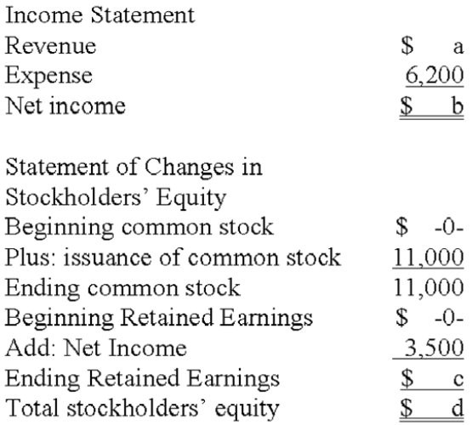

140) The following is a partial set of financial statements prepared for the company's first year of operations. All transactions were for cash.

Required:
Fill in the blanks indicated by the alphabetic letters in the following financial statements.

Income Statement
Service revenue $ 44,000
Operating expenses a
Net income $ b

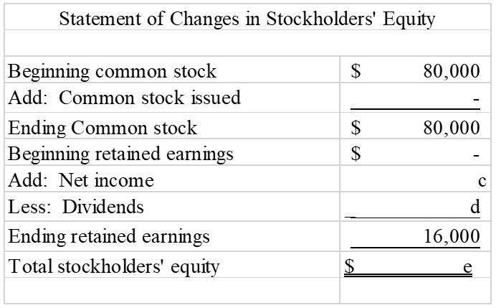
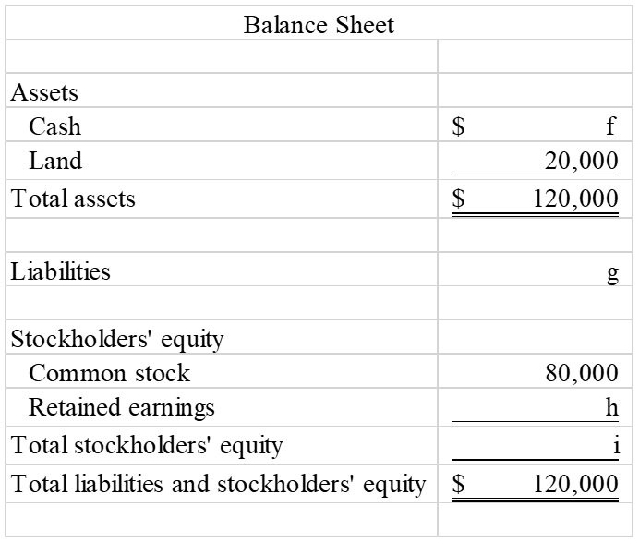
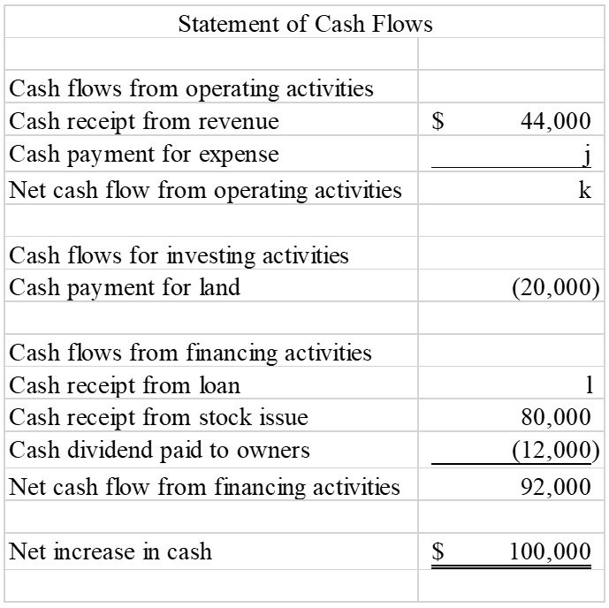

141) The following transactions apply to the Garber Corporation for Year 1, its first year in business.
1) Issued stock to investors, $48,000.
2) The company borrowed $42,000 cash from the bank.
3) Services were provided to customers and $50,000 cash was received.
4) The company acquired land for $44,000.
5) The company paid $34,000 rent for the building where it does its business.
6) The company paid $3,200 for supplies that were used during the period.
7) The company sold the land acquired in item 5 for $44,000.
8) A dividend of $1,000 was paid to the owners.
9) Repaid $20,000 of the loan described in item 2.

Required:
a. Prepare an income statement, statement of changes in equity, and balance sheet for Year 1.
b. Prepare a statement of cash flows for Year 1.

142) Rosemont Company began operations on January 1, Year 1, and on that date issued stock for $60,000 cash. In addition, Rosemont borrowed $50,000 cash from the local bank. The company provided services to its customers during Year 1 and received $35,000. It purchased land for $70,000. During the year, it paid $10,000 cash for salaries. Stockholders were paid cash dividends of $8,000 during the year.

Required:
a) List the transactions from the information above (for example, issued common stock for $60,000) and indicate in which section of the statement of cash flows each transaction would be reported.
b) What would the amount be for net cash flows from operating activities?
c) What would be the end-of-year balance for the cash account?
d) What would be the amount of the total assets for the Rosemont Company at the end of Year 1?
e) What would be the end-of-year balance for the Retained Earnings account?

143) The Campbell Company began operations on January 1, Year 1 and on that date issued $60,000 of common stock for cash. In addition, the company borrowed $40,000 from the bank. It provided services to its customers during Year 1 and received $72,000 cash. During the year, it paid $80,000 cash for land, $50,000 for salaries, and $10,000 in cash dividends to the owners.

Required:
1) Show the effects of the above transactions on the accounting equation. (Start by using appropriate element and account headings). Enter a "0" if a transaction does not affect a given account.
2) Prepare an income statement and a balance sheet for the Year 1 accounting period.

144) Pinehurst Company was formed in Year 1 and experienced the following accounting events during the year:
1. Issued common stock for $15,000 cash
2. Earned cash revenue of $28,000
3. Paid cash expenses of $20,500.
These were the only events that affected the company during the year.

Required:
a) Show the effects of the above transactions on the accounting equation. (Start by using appropriate element and account headings). Leave the cell blank if a transaction does not affect a given account.
b) Prepare an income statement for Year 1 and a balance sheet as of December 31, Year 1.

145) Fieldstone Company was founded on January 1, Year 1. During Year 1, the company experienced the following events:
1. Received cash revenue of $25,500
2. Paid cash expenses of $20,000
3. Issued common stock for $30,000 cash
4. Paid cash dividend of $2,000 to owners.

Required:
a) Show the effects of the above transactions on the accounting equation. (Start by using appropriate element and account headings). Leave the cell blank if a transaction does not affect a given account.
b) Prepare the Year 1 income statement and balance sheet for Fieldstone Company.

146) Kent Corporation is trying to prepare their annual financial statements. From the list below, indicate whether the item should appear on the Income Statement, Balance Sheet, Statement of Changes in Stockholders' Equity or Statement of Cash Flows. Use IS for Income Statement, BS for Balance Sheet, SE for Statement of Changes in Stockholders' Equity and CF for Statement of Cash Flows. Note that some items may appear on more than one financial statement.

a. Total Assets
b. Land
c. Common Stock
d. Net Change in Cash
e. Revenue
f. Notes Payable
g. Stockholders' Equity
h. Total Liabilities
i. Expenses
j. Net Income
k. Ending Cash Balance
l. Beginning Cash Balance
m. Dividends

147) Lace Corporation is trying to prepare the balance sheet for year-end. For each of the accounts, indicate whether it should be reported as an Asset, Liability, or Equity account.

a. Common Stock
b. Land
c. Note Payable
d. Cash
e. Retained Earnings

148) Using the information provided in Garber Corporation's balance sheet. Calculate the following financial statement elements as a percentage of assets:

a) the total liabilities
b) common stock
c) retained earnings
d) total stockholder's equity
e) total liabilities and stockholders' equity
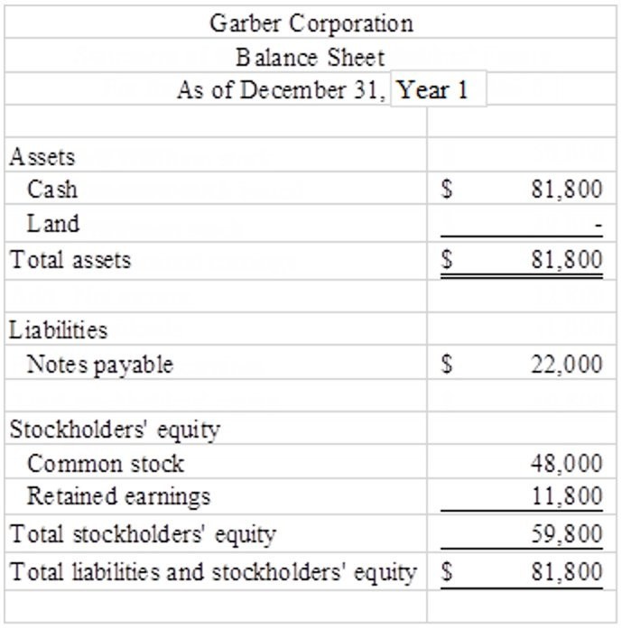

149) Car Company recorded this month's transactions in the accounting equation shown below. Based on the accounting equation, what is the maximum dividend the company could pay to shareholders?
