Lesson 1 GEOGRAPHIC PERSPECTIVES
Part 1 - SCIENTIFIC METHOD

For use with Chapter 1 - Physical Geography: Earth Environments and Systems
Materials needed: pencil
Part 1 Goals: The student will be able to:
• Define geography and its subfields
• Recognize studies that fall in physical geography, cultural geography, regional geography, and geographic techniques
• Identify alternative and null hypotheses
• Use the subfields of geography to describe a familiar favorite place
Reading Assignment: Read the chapter paying particular attention to pages 2 through 13

Materials to be supplied: No additional materials are needed.

Time: Approximately 30 minutes to complete activities. Discussion and the lesson plan below can be used to fill additional time.

Prerequisites: None.

Comments: The answers to the matching activity are provided below. In regards to the subfield, the preferred answers are given, but some latitude should be permitted. For example, a human geographer might study food habits around the country and use a regional approach to discuss the results (question 21). In that the example is emphasizing the regional pattern, the answer has classified it as regional. Similarly, question 19 is from the field of geology but is something that can be taught in this course. The real purpose is to get students to recognize geography as a science that applies the scientific method and to direct the students to think about what is geographical and how geography integrates all of these concerns into a unique discipline that shares concerns with other disciplines.

Suggested plan: Provide a brief introduction to the subfields of geography and the scientific method. Then have the students work through the first activity. Discuss the answers. Emphasize the diversity of the field, and that geographical research crosses both its own subfields and traditional disciplines. After the discussion, have the students complete Activity 2. Have them submit this sheet, and retain it for use in Lesson 27 when this response will be compared to a similar activity at the end of the course. As completion, you may ask several students to voluntarily read their essays, and discuss the geographical descriptions they provide.

Suggested assessment: The first column of Activity 1 can be scored as one point per question, if desired; however, as an introduction to the course, this lesson might be graded on a criterion reference basis. Three or four parts of the activity can be scored for completion/non-completion. Column one, column two, and the essay comprise three parts. Class participation could represent the fourth component.

Lesson 1 GEOGRAPHICAL PERSPECTIVES

Part 2 - SYSTEMS

For use with Chapter 1 - Physical Geography: Earth Environments and Systems
Materials needed: Pencil
Part 2 Goals: The student will be able to:
• Describe an example of a system and how one functions
• Differentiate between open and closed systems
• Apply systems theory to a stream system
• Identify positive and negative feedback as they relate to a system
Reading Assignment: Read the chapter paying particular attention to pages 13 through 16

Materials to be supplied: No additional materials are needed.

Time: Approximately 15 minutes

Prerequisites: Fundamental math concepts

Comments: This presents a basic model of a system and requires simple mathematical computation to be shown on the paper. In that the work is to be shown, a calculator should not be required.

Suggested plan: Provide a brief introduction to the concept of systems theory. Then have the students complete the activities. Discussion may follow.

Suggested assessment: 5 questions, 2 formulas, and four mathematical computations to yield a final result are required. Awarding the final computation as 2 points results in an activity worth 12 points.

Review Questions
The field that studies earth, location, people, environment, and change is geography. Everything around us constitutes our environment. The processes and features on Earth and their relationship with humans are studied in physical geography. The study of the patterns and functions of human activity is human geography. Studying the physical and human geography of an area is regional geography. Geographic tools, methods, and technology are studied in the subfield called geographic techniques. A general and rigorous framework for research to build knowledge is the scientific method. A statement or question for investigation is a hypothesis. A statement of the anticipated results from research investigation is the alternate hypothesis. The research statement that is statistically tested is the null hypothesis. Explanations or predictions about outcomes under specific conditions are theories. Relationships or processes that hold true under specified conditions are laws.

Lesson 1 GEOGRAPHIC PERSPECTIVES
Part 1 - SCIENTIFIC METHOD

Part 1–Activity 1
Read the statements below. Identify whether the statement is not a hypothesis (X), an alternative hypothesis (A) or null hypothesis (N). If it is a hypothesis, identify whether the study belongs to physical geography (P), human geography (H), regional geography (R), geographic techniques (G), or is another science and non-geographical (S). The first one is done as an example.

___A___ ___P___ 1. More rain falls in front of this building than in back of this building.
___N___ ___R____ 2. The mean population density in Detroit is the same as in Denver.
___N___ ___P____ 3. City and suburban temperatures are the same.
___X___ ___-____ 4. It seems like it always rains on Wednesday.
___X____ ___-___ 5. What happens during an earthquake?
___A____ ___R____ 6. New York has more Spanish speakers than Pennsylvania.
___X___ ___-____ 7. When did Beethoven die?
___A____ ___P____ 8. Air pressure is more variable in winter than in summer.
___A____ ___H____ 9. A larger percentage of the youth rent movies than adults.
___X____ ___-____ 10. Why does snow fall?
___A____ ___P____ 11. More tornado deaths occur in May than in June.
___A____ ___G____ 12. Dot maps are easier to read than choropleth maps.
___X____ ___-____ 13. Many Italian immigrants were Catholics.
___A____ ___H____ 14. More Hoosiers attend basketball games than football games.
___N___ ___P____ 15. Lizard and cacti tolerate the same drought conditions.
___A____ ___R____ 16. Europe has a lower fertility rate than North America.
___N____ ___H____ 17. Men and women fear the same locations in a city.
___N____ ___H____ 18. Grocery store sales will be the same regardless of the side of the street on which they locate.
___N____ ___S____ 19. A penny and calcite have the same hardness.
___A____ ___S____ 20. Teaching with a chalkboard is less effective than using a data projector.
____N___ ___R____ 21. Beans are served similarly in the northern and southern states.

Part 1–Activity 2
Considering what you know and what has been said above, write a description of a familiar favorite place. Identify its location and describe the physical, human, and regional characteristics of the place. Give as much geographical information as you can.

Lesson 1 GEOGRAPHICAL PERSPECTIVES

Part 2 - SYSTEMS

Part 2--Activity 1
Identify whether the following descriptions illustrate open systems, closed systems, positive feedback, negative feedback, or equilibrium.

___closed system_____ 1. A battery powered wrist watch
___positive feedback_ 2. A drop in the level of a reservoir because of a leak in a dam.
__negative feedback_ 3. An increase in a checking account balance because of a tax rebate.
___equilibrium______ 4. The mean temperature in a house in the winter when the furnace is functioning properly.
___open system______ 5. The internet

Part 2—Activity 2
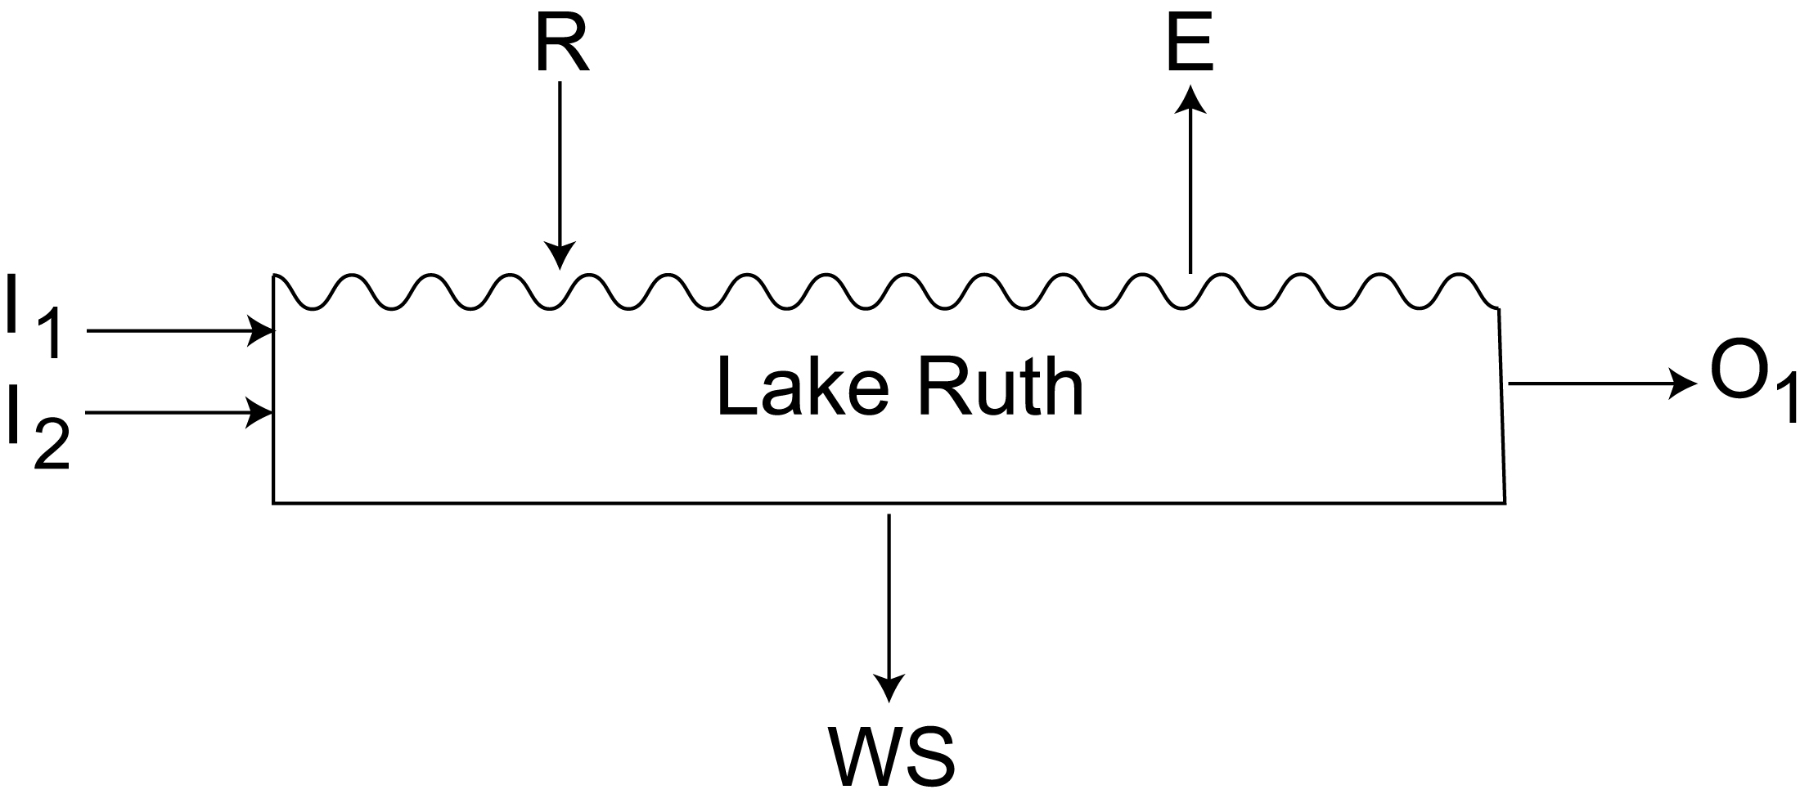
Scenic Lake Ruth, a small lake located in west central Illinois, has two rivers flowing into it from the north. We can think of those rivers as INPUT 1 (I₁) and INPUT 2 (I₂). An additional input is the rainfall (R) that occurs over Lake Ruth. The lake has three outputs of water: evaporation (E) from the lake’s surface; water seeping into the subsurface rock layers (WS); and the water flowing out of a single river to the south of the lake (O₁). The figure below depicts these inputs and outputs. The operation of a system may be assessed by using a budget approach that evaluates changes in the inputs, outputs, and storage within the system. Write a formula using the symbols above to show the amount of water in Lake Ruth (LR).

LR = ____(I₁ + I₂ + R )-( E + WS + O₁)_______________________________________

From July 1, 1998 through July 8, 1998, the level of Lake Ruth did not change. Yet during that period, 1000 m³ of water flowed into the lake from river 1 and 1500 m³ of water entered from river 2. Evaporation during that time was 350 m³ while seepage was 100 m3 of water. If rainfall during this period was 120 m³, calculate the volume of water that had to flow out of the river at the south end of Lake Ruth. Write the equation on the line, AND SHOW YOUR CALCULATIONS IN THE SPACE BELOW. Circle your answer.

O₁ ₌ I₁ + I₂ + R – E – WS 2170 m³______________

1000 m³ + 1500 m³ + 120 m³ – 350 m³ – 100 m³ = 2170 m³

In that the lake level does not change, input and output must be equal.

