Instructor’s Solution Manual to Chapter Exercises in
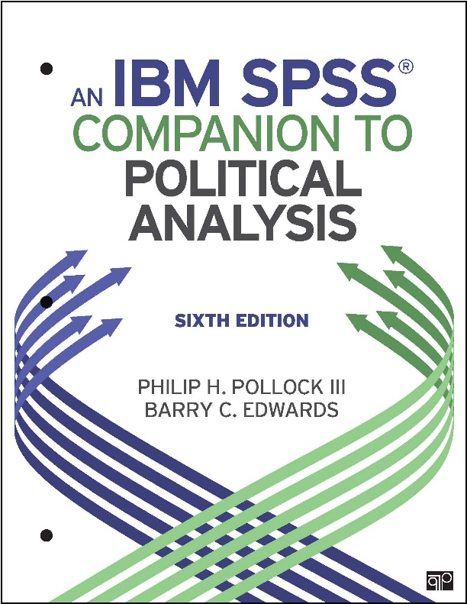
An IBM SPSS Companion to Political Analysis, Sixth Edition
By Philip H. Pollock II and Barry C. Edwards

Solutions to Exercises in | Page
Getting Started (No exercises) | 2
Chapter 1: Introduction to SPSS | 3
Chapter 2: Descriptive Statistics | 6
Chapter 3: Transforming Variables | 20
Chapter 4: Making Comparisons | 24
Chapter 5: Making Controlled Comparisons | 37
Chapter 6: Making Inferences about Sample Means | 48
Chapter 7: Chi-Square and Measures of Association | 51
Chapter 8: Correlation and Linear Regression | 57
Chapter 9: Dummy Variables and Interaction Effects | 66
Chapter 10: Logistic Regression | 74
Chapter 11: Doing Your Own Political Analysis | 83

Version 1.3, Last Updated May 8, 2019

Getting Started
There are no exercises at end of the Getting Starting section.

Chapter 1: Introduction to SPSS

1.
A. 26 $170,000 or over
B. 0 Never

2.
Display names
Alphabetical

3.
A. General Happiness
B. 1

4.
A.
General Happiness
 |  | Frequency | Percentage | Valid percentage | Cumulative percentage
Valid | VERY HAPPY | 869 | 30.3 | 30.4 | 30.4
 | PRETTY HAPPY | 1579 | 55.1 | 55.2 | 85.6
 | NOT TOO HAPPY | 411 | 14.3 | 14.4 | 100.0
 | Total | 2859 | 99.7 | 100.0
Missing | System | 8 | .3
Total |  | 2867 | 100.0

B. Word-formatted table looks something like this:
General Happiness | Frequency | Percentage | Cumulative
Very Happy | 869 | 30.4 | 30.4
Pretty Happy | 1579 | 55.2 | 85.6
Not Too Happy | 411 | 14.4 | 100.0
Total | 2859 | 100.0

Syntax for solution
* with GSS dataset

FREQUENCIES VARIABLES=happy
/ORDER=ANALYSIS.

5.
SPSS file type | File name extension
Dataset | .sav
Output | .spv
Syntax | .sps

6.
A. hs_yrs_ss
B. vep16_turnout
C. attend_pct
D. volunteer_percent

7.
NES variable “marital”
Numeric code | Value label
1 | Married, spouse present
2 | Married, spouse absent (volunteered)
3 | Widowed
4 | Divorced
5 | Separated
6 | Never married

8.
Here are the variable descriptions in the Appendix. Students were asked to describe these variables in “their own words” so their wording should vary without changing the essential meaning.
A. Total fertility rate: Number children born per woman (CIA)
B. Percentage of population aged 15–49 with HIV. From World Economic Forum
C. Number infants dying before age one per 1,000 live births. From World Bank’s World Development Indicators
D. Public expenditure on health as a percentage of GDP (UN)
E. Age-standardized death rates from non-communicable diseases per 100,000 people (UN)

