CHAPTER 1: The Earth in Context
LEARNING OBJECTIVES
1A. Characterize how people’s perceptions of the Earth’s place in the Universe have changed over the centuries.
1B. Explain modern concepts concerning the basic architecture of our Universe and its components.
1C. Outline the evidence for the expanding Universe and the Big Bang theory.
1D. Explain the nebula theory, a scientific model that describes how stars and planets form.
1E. Describe the nature of the magnetic field and atmosphere that surround our planet.
1F. List the distinct interacting realms within the Earth System.
1G. Distinguish the internal layers (crust, mantle, and core) of the Earth.
1H. Explain the relationship between the lithosphere and the asthenosphere.

MULTIPLE CHOICE

1. The study of the Universe, its structure, and its history is called __________.
a. | cosmetology
b. | cosmology
c. | astrology
d. | petrology

ANS: B DIF: Easy REF: 1.1
OBJ: 1A. Characterize how people’s perceptions of the Earth’s place in the Universe have changed over the centuries. MSC: Remembering

2. The idea that the Earth sits motionless in the Universe at the center of a revolving globe of stars, with the Moon and planets in orbit around the Earth, is the ___________ model of the Universe.
a. | heliocentric
b. | anthropomorphic
c. | geocentric
d. | volcanic

ANS: C DIF: Medium REF: 1.1
OBJ: 1A. Characterize how people’s perceptions of the Earth’s place in the Universe have changed over the centuries. MSC: Understanding

3. When was the heliocentric model of the Universe, which asserts that the Sun sits at the center of our solar system and that the Earth is just one of several planets that orbit around the Sun, developed?
a. | before the dawn of recorded history
b. | during the time of the ancient Greeks 2000 years ago
c. | during the Renaissance in the 15th century
d. | about one hundred years ago during World War I

ANS: C DIF: Medium REF: 1.1
OBJ: 1A. Characterize how people’s perceptions of the Earth’s place in the Universe have changed over the centuries. MSC: Understanding

4. In the heliocentric model,
a. | the Earth orbits around the Sun.
b. | the Sun orbits around the Earth.
c. | the Earth is a stationary planet.
d. | Mercury and Venus orbit around the Sun, but all other planets orbit around the Earth.

ANS: A DIF: Easy REF: 1.2
OBJ: 1A. Characterize how people’s perceptions of the Earth’s place in the Universe have changed over the centuries. MSC: Remembering

5. Ancient astronomers observed that the positions of _______ in the sky remain fixed relative to each other, while the locations of ________ move over time.
a. | the Sun and Moon; the stars
b. | the stars; the planets
c. | the planets; the Sun and Moon
d. | the Sun and Moon; the planets

ANS: B DIF: Medium REF: 1.2
OBJ: 1A. Characterize how people’s perceptions of the Earth’s place in the Universe have changed over the centuries. MSC: Applying

6. Which of the following is a characteristic shared by planets and asteroids?
a. | It orbits a star.
b. | It is nearly spherical in shape.
c. | It has one or more moons.
d. | It has cleared its neighborhood of other objects.

ANS: A DIF: Medium REF: 1.2
OBJ: 1B. Explain modern concepts concerning the basic architecture of our Universe and its components. MSC: Evaluating

7. Aside from the Earth, the terrestrial planets are
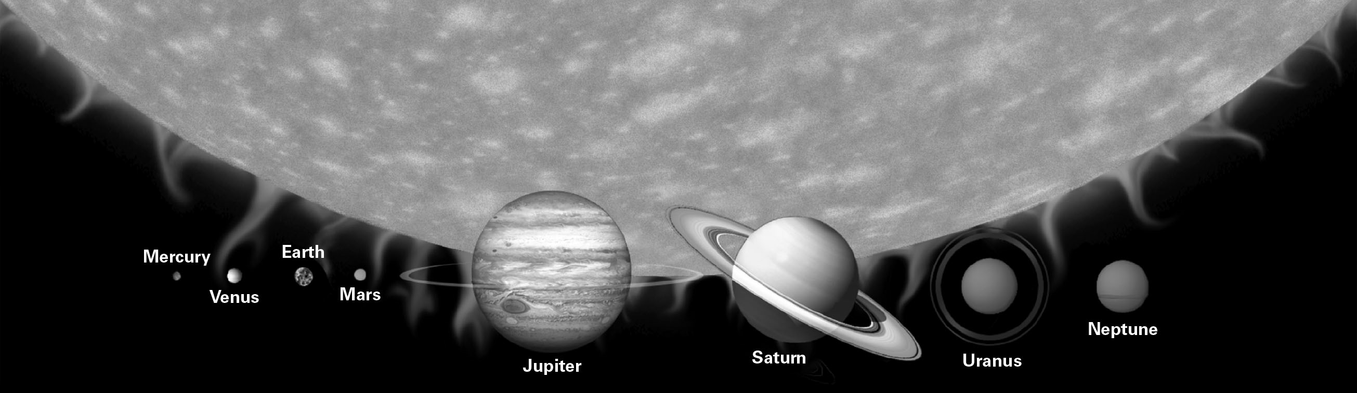
a. | Mars, Mercury, and Venus.
b. | Mars, Venus, and Jupiter.
c. | Jupiter, Saturn, Uranus, and Neptune.
d. | Mars and Saturn.

ANS: A DIF: Easy REF: 1.2
OBJ: 1B. Explain modern concepts concerning the basic architecture of our Universe and its components. MSC: Evaluating

8. The giant planets are
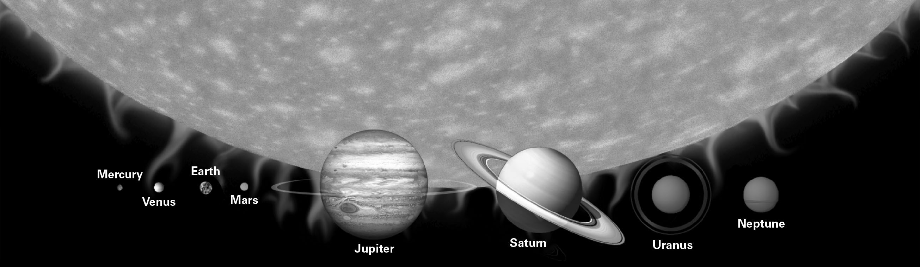
a. | Mars, Mercury, and Venus.
b. | Mars, Venus, and Jupiter.
c. | Jupiter, Saturn, Uranus, and Neptune.
d. | Uranus, Saturn, and Neptune.

ANS: C DIF: Easy REF: 1.2
OBJ: 1B. Explain modern concepts concerning the basic architecture of our Universe and its components. MSC: Remembering

9. Terrestrial planets are mainly composed of ________, while the giant planets are made predominantly of ________.
a. | volatiles; rock and metals
b. | rock and metals; volatiles
c. | refractory materials; volatiles and metals
d. | volatiles and metals; refractory materials

ANS: B DIF: Difficult REF: 1.2
OBJ: 1B. Explain modern concepts concerning the basic architecture of our Universe and its components. MSC: Applying

10. Which of the following planets is MOST similar to the Earth?
a. | Neptune
b. | Mercury
c. | Jupiter
d. | Uranus

ANS: B DIF: Medium REF: 1.2
OBJ: 1B. Explain modern concepts concerning the basic architecture of our Universe and its components. MSC: Analyzing

11. Which of the following distinguishes moons from asteroids?
a. | Moons orbit a star.
b. | Moons orbit a planet.
c. | Moons are stationary in space.
d. | Moons are composed of rock.

ANS: B DIF: Medium REF: 1.2
OBJ: 1B. Explain modern concepts concerning the basic architecture of our Universe and its components. MSC: Analyzing

12. A light year is a unit that measures
a. | time.
b. | distance.
c. | mass.
d. | luminous intensity.

ANS: B DIF: Easy REF: 1.2
OBJ: 1B. Explain modern concepts concerning the basic architecture of our Universe and its components. MSC: Understanding

13. According to the Big Bang theory,
a. | the Earth is much older than the rest of the Universe.
b. | the Universe is much older than the Earth.
c. | the Earth and the Universe formed at about the same time.
d. | there is no way of knowing how old the Universe might be.

ANS: B DIF: Medium REF: 1.3
OBJ: 1C. Outline the evidence for the expanding Universe and the Big Bang theory.
MSC: Analyzing

14. The best estimate of when the Universe formed is
a. | 13.8 Ma.
b. | 13.8 Ga.
c. | 4.57 Ma.
d. | 4.57 Ga

ANS: B DIF: Medium REF: 1.3
OBJ: 1C. Outline the evidence for the expanding Universe and the Big Bang theory.
MSC: Remembering

15. According to the Big Bang theory, our Universe is ________.
a. | expanding
b. | contracting
c. | static
d. | periodically contracting and expanding

ANS: A DIF: Easy REF: 1.3
OBJ: 1C. Outline the evidence for the expanding Universe and the Big Bang theory.
MSC: Applying

16. When the Universe was very young, almost all matter consisted of the elements ______ and _________.
a. | carbon; iron
b. | uranium; lead
c. | hydrogen, helium
d. | oxygen, nitrogen

ANS: C DIF: Easy REF: 1.3
OBJ: 1D. Explain the nebula theory, a scientific model that describes how stars and planets form.
MSC: Remembering

17. The first generation of stars in our Universe formed from the collapse of ________.
a. | protoplanets
b. | nebulae
c. | supernovae
d. | the Big Bang

ANS: B DIF: Medium REF: 1.3
OBJ: 1D. Explain the nebula theory, a scientific model that describes how stars and planets form.
MSC: Understanding

18. The current scientific explanation for the organizing of matter into planets, moons, asteroids, and comets in our Solar System is the
a. | expanding Universe theory.
b. | nebular theory.
c. | Big Bang theory.
d. | theory of plate tectonics.

ANS: B DIF: Difficult REF: 1.4
OBJ: 1D. Explain the nebula theory, a scientific model that describes how stars and planets form.
MSC: Evaluating

19. By far the most common elements in the Universe and in our Solar System are
a. | nitrogen and oxygen.
b. | iron and manganese.
c. | hydrogen and helium.
d. | hydrogen and oxygen.

ANS: C DIF: Easy REF: 1.3 | 1.4
OBJ: 1D. Explain the nebula theory, a scientific model that describes how stars and planets form.
MSC: Remembering

20. Intermediate weight elements (heavier than helium but lighter than iron) form during the life cycles of ________.
a. | stars
b. | nebulae
c. | asteroids
d. | black holes

ANS: A DIF: Medium REF: 1.3 | 1.4
OBJ: 1D. Explain the nebula theory, a scientific model that describes how stars and planets form.
MSC: Applying

21. Atoms that are heavier than iron are generally produced by
a. | fission reactions within stars.
b. | fusion reactions within stars.
c. | explosions of supernovas.
d. | the Big Bang.

ANS: C DIF: Difficult REF: 1.4
OBJ: 1D. Explain the nebula theory, a scientific model that describes how stars and planets form.
MSC: Understanding

22. The great abundance of heavy elements on Planet Earth tells us that the Sun must be _______.
a. | a first-generation star
b. | a nebula
c. | at least a third-generation star
d. | nearing the end of its stellar life cycle

ANS: C DIF: Difficult REF: 1.4
OBJ: 1D. Explain the nebula theory, a scientific model that describes how stars and planets form.
MSC: Applying

23. Volatile materials occur as _______, while refractory materials exist as ________.
a. | gases; solids
b. | moons; planets
c. | red giant stars; supernovae
d. | liquids; gases

ANS: A DIF: Medium REF: 1.4
OBJ: 1D. Explain the nebula theory, a scientific model that describes how stars and planets form.
MSC: Applying

24. When did our solar system organize from a collapsing solar nebula into a system of Sun, planets, moons, comets, and asteroids?
a. | 13.8 Ga
b. | 4.57 Ga
c. | 2.25 Ga
d. | 0.54 Ga

ANS: B DIF: Easy REF: 1.4
OBJ: 1D. Explain the nebula theory, a scientific model that describes how stars and planets form.
MSC: Applying

25. The term for the separation of the Earth into internal layers early in our planet’s history
is _______.
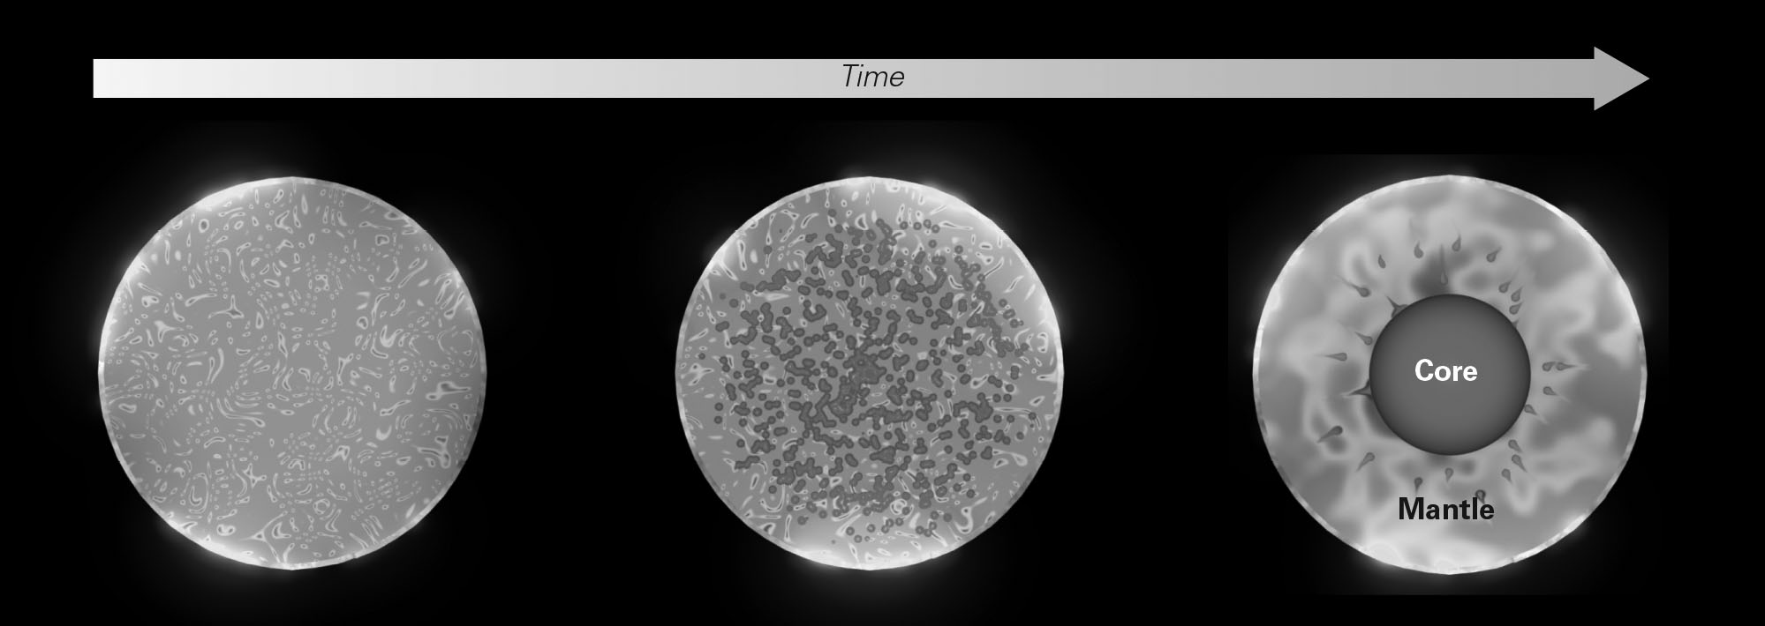
a. | accretion
b. | differentiation
c. | protoplanetary collapse
d. | nucleosynthesis

ANS: B DIF: Medium REF: 1.4
OBJ: 1G. Distinguish the internal layers (crust, mantle, and core) of the Earth.
MSC: Understanding

26. Why did the early Earth differentiate into core and mantle?
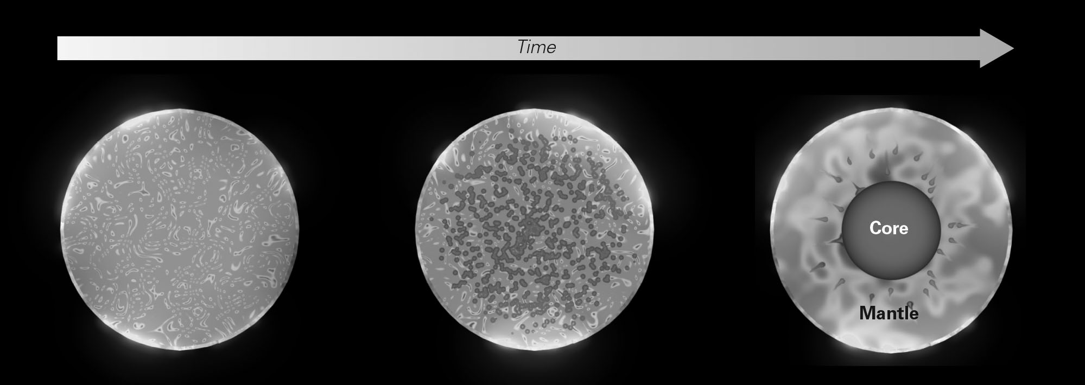
a. | Gravity pulled denser material to the interior and left less dense material on the outside.
b. | Nucleosynthesis created an outer mantle layer from fusion of the elements in the core.
c. | Gravity first pulled denser material into a protoplanet, and only later was mantle material added.
d. | Spinning on its axis caused less dense mantle material to float outside the core.

ANS: A DIF: Difficult REF: 1.4
OBJ: 1G. Distinguish the internal layers (crust, mantle, and core) of the Earth.
MSC: Analyzing

27. Differentiation of the core from the mantle early in the Earth’s history was possible because the planet was ________ at the time.
a. | very cold
b. | very hot
c. | very small
d. | the only planet in the Solar System

ANS: B DIF: Medium REF: 1.4
OBJ: 1G. Distinguish the internal layers (crust, mantle, and core) of the Earth.
MSC: Understanding

28. Which of the following best describes how the Earth’s Moon formed?
a. | The Earth and the Moon formed at the same time when a protoplanet split apart.
b. | Early in the history of our Solar System, an asteroid was captured by the Earth’s gravity and became the Moon.
c. | Early in the history of our Solar System, a protoplanet collided with the Earth, sending debris into orbit that coalesced to form the Moon.
d. | Early in the history of our Solar System, a group of comets was captured by the Earth’s gravity and coalesced to form the Moon.

ANS: C DIF: Medium REF: 1.5
OBJ: 1D. Explain the nebula theory, a scientific model that describes how stars and planets form.
MSC: Analyzing

29. The shape of the Earth’s magnetic field is approximately that of a
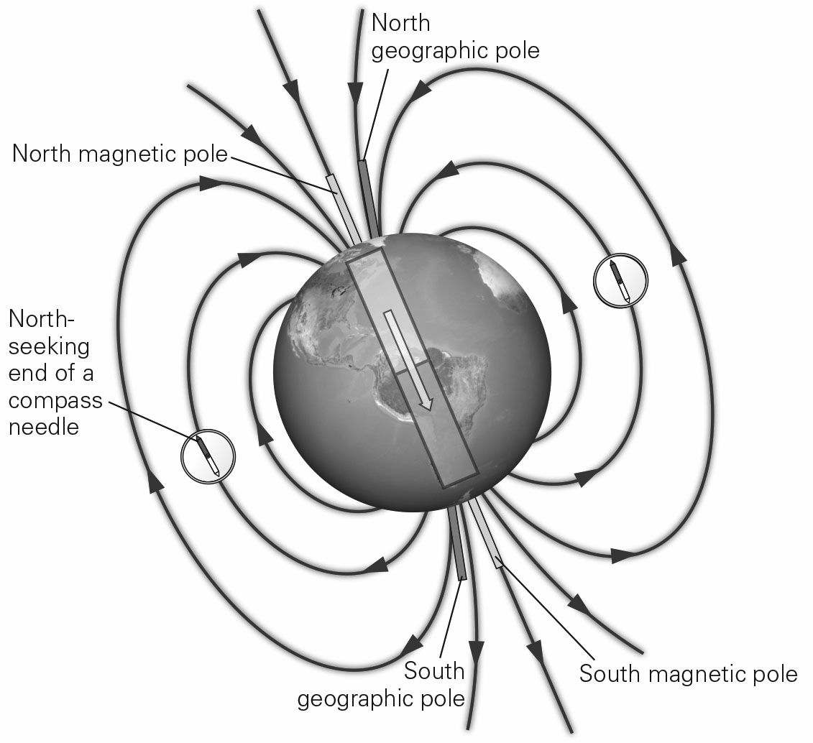
a. | monopole, as would be produced by just one pole of a magnet.
b. | dipole, such as that produced by a bar magnet.
c. | torus, a doughnut-shaped ring parallel to the Earth’s equator.
d. | sphere, following the shape of the Earth.

ANS: B DIF: Easy REF: 1.5
OBJ: 1E. Describe the nature of the magnetic field and atmosphere that surround our planet.
MSC: Remembering

30. How do the North Magnetic Pole and the North Geographic Pole relate to each other on the globe?
a. | Both poles occur at exactly the same place.
b. | The North Magnetic Pole is near the North Geographic Pole.
c. | The North Magnetic Pole is on opposite side of the Earth from the North Geographic Pole.
d. | The North Magnetic Pole is along the equator, far removed from the North Geographic Pole.

ANS: B DIF: Easy REF: 1.5
OBJ: 1E. Describe the nature of the magnetic field and atmosphere that surround our planet.
MSC: Evaluating

31. The Earth’s surface is protected from solar wind and cosmic radiation by
a. | the Earth’s gravitational field.
b. | the Earth’s magnetic field.
c. | a large, metallic shield launched into orbit by NASA in the 1960s.
d. | a powerful stream of ions emitted by the Sun.

ANS: B DIF: Medium REF: 1.5
OBJ: 1E. Describe the nature of the magnetic field and atmosphere that surround our planet.
MSC: Understanding

32. An aurora is produced when
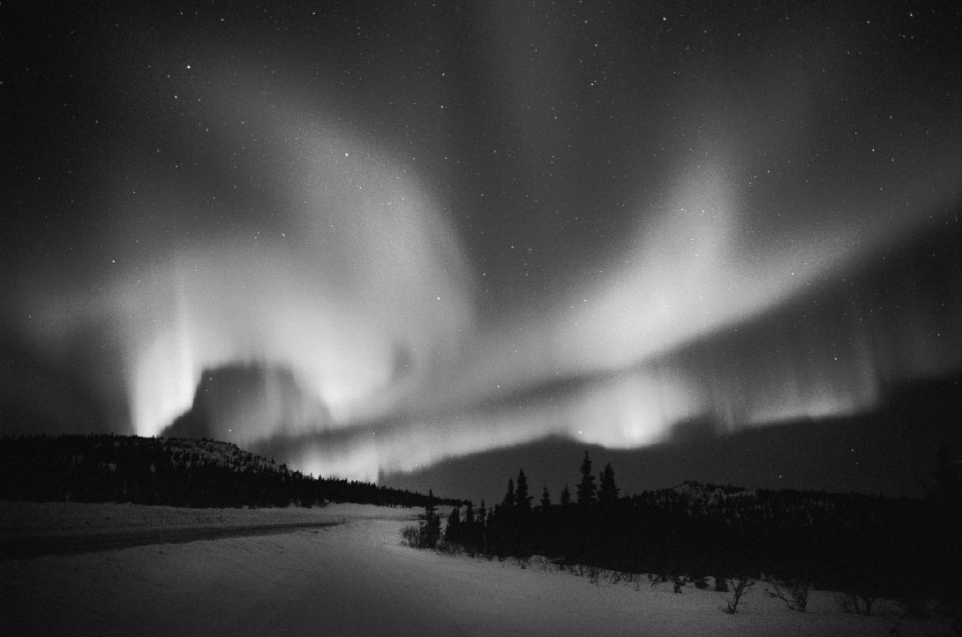
a. | charged particles flow toward the magnetic poles and excite atmospheric gases.
b. | swamp gases rise from the Arctic tundra and react with the upper atmosphere.
c. | radiation in the Van Allen belts can be seen on a clear, cold night.
d. | lightning travels from cloud to cloud rather than cloud to ground.

ANS: A DIF: Difficult REF: 1.6
OBJ: 1E. Describe the nature of the magnetic field and atmosphere that surround our planet.
MSC: Understanding

33. The atmosphere is divided into several distinct layers. From the ground up they are, in order,
a. | stratosphere, troposphere, mesosphere, and thermosphere.
b. | troposphere, stratosphere, thermosphere, and mesosphere.
c. | troposphere, stratosphere, mesosphere, and thermosphere.
d. | stratosphere, troposphere, thermosphere, and mesosphere.

ANS: C DIF: Easy REF: 1.6
OBJ: 1E. Describe the nature of the magnetic field and atmosphere that surround our planet.
MSC: Remembering

34. Presently, the Earth’s atmosphere is dominated by which two gases?
a. | hydrogen and helium
b. | oxygen and carbon dioxide
c. | nitrogen and oxygen
d. | carbon dioxide and sulfur dioxide

ANS: C DIF: Easy REF: 1.6
OBJ: 1E. Describe the nature of the magnetic field and atmosphere that surround our planet.
MSC: Remembering

35. Atmospheric pressure is caused by __________.
a. | the weight overlying air molecules pushing down from higher in the atmosphere
b. | the increasing size of air molecules lower in the atmosphere
c. | interactions between air molecules and the Earth’s magnetic field
d. | the solar wind pushing on the atmosphere

ANS: A DIF: Medium REF: 1.6
OBJ: 1E. Describe the nature of the magnetic field and atmosphere that surround our planet.
MSC: Analyzing

36. Why is it difficult if not impossible for towns and cities to exist much higher than 5 km in elevation?
a. | because solar radiation kills most life above this elevation
b. | because temperatures are too cold
c. | because low air pressure leads to not enough oxygen for survival
d. | because humans have never explored high elevation regions of the globe

ANS: C DIF: Medium REF: 1.6
OBJ: 1E. Describe the nature of the magnetic field and atmosphere that surround our planet.
MSC: Analyzing

37. How does air temperature change with elevation in the troposphere, the lowest layer of the Earth’s atmosphere?
a. | It slowly rises with increasing elevation.
b. | It becomes much lower at higher elevations, reaching well below the freezing point of water.
c. | It remains constant regardless of elevation.
d. | It becomes lower with increasing elevation, but never drops below the freezing point of water.

ANS: B DIF: Medium REF: 1.6
OBJ: 1E. Describe the nature of the magnetic field and atmosphere that surround our planet.
MSC: Analyzing

38. How much of the Earth’s surface is occupied by the oceans?
a. | 12%
b. | 30%
c. | 50%
d. | 70%

ANS: B DIF: Medium REF: 1.6
OBJ: 1F. List the distinct interacting realms within the Earth System.
MSC: Remembering

39. How does the volume of water in the oceans compare with the total volume of freshwater in lakes and rivers?
a. | They are about equal in volume.
b. | The oceans contain slightly more water than lakes and rivers do.
c. | The oceans contain much less water than lakes and rivers do.
d. | The oceans contain much more water than lakes and rivers do.

ANS: D DIF: Easy REF: 1.6
OBJ: 1F. List the distinct interacting realms within the Earth System.
MSC: Analyzing

40. How does the deepest part of the ocean compare with the height of Earth’s tallest mountains?
a. | The tallest mountains are much further above sea level than the deepest parts of the ocean are below sea level.
b. | The deepest parts of the ocean are much further below sea level than the tallest mountains are above sea level.
c. | The height of the tallest mountains is about the same as the deepest depths in the ocean.
d. | We don’t know because we have not yet found the deepest part of the ocean.

ANS: B DIF: Medium REF: 1.6
OBJ: 1F. List the distinct interacting realms within the Earth System.
MSC: Analyzing

41. Which of the following is a rock formed from solidifying of magma or lava?
a. | igneous rock
b. | sedimentary rock
c. | metamorphic rock
d. | differentiated rock

ANS: A DIF: Easy REF: 1.6
OBJ: 1F. List the distinct interacting realms within the Earth System.
MSC: Remembering

42. Most minerals within the Earth contain the element _________
a. | silicon.
b. | nitrogen.
c. | carbon.
d. | hydrogen.

ANS: A DIF: Medium REF: 1.6
OBJ: 1F. List the distinct interacting realms within the Earth System.
MSC: Applying

43. The density of rocks is generally related to composition; rocks with higher silica contents tend to be less dense. Which of the following places rock compositions in order of increasing density?
a. | felsic, intermediate, ultramafic, mafic
b. | ultramafic, mafic, intermediate, felsic
c. | felsic, intermediate, mafic, ultramafic
d. | mafic, ultramafic, intermediate, felsic

ANS: C DIF: Difficult REF: 1.6
OBJ: 1F. List the distinct interacting realms within the Earth System.
MSC: Applying

44. The metal alloy that makes up the core of the Earth is ________ compared to the rocky mantle.
a. | less dense
b. | denser
c. | very similar in chemistry and density
d. | distinct in chemistry but of very similar density

ANS: B DIF: Medium REF: 1.7
OBJ: 1G. Distinguish the internal layers (crust, mantle, and core) of the Earth.
MSC: Applying

45. The study of which process has proven very useful in determining the structure and layering of the Earth’s interior?
a. | earthquakes
b. | magnetism
c. | tides
d. | glaciers

ANS: A DIF: Easy REF: 1.7
OBJ: 1G. Distinguish the internal layers (crust, mantle, and core) of the Earth.
MSC: Applying

46. The most abundant elements in the Earth’s crust are
a. | oxygen and silicon.
b. | carbon and nitrogen.
c. | iron and nickel.
d. | sodium and chlorine.

ANS: A DIF: Easy REF: 1.7
OBJ: 1G. Distinguish the internal layers (crust, mantle, and core) of the Earth.
MSC: Remembering

47. Compared to oceanic crust, continental crust is
a. | thicker.
b. | thinner.
c. | about the same thickness.
d. | In some places continental crust is thicker; in some places oceanic crust is thicker. There is no consistent pattern.

ANS: A DIF: Easy REF: 1.7
OBJ: 1G. Distinguish the internal layers (crust, mantle, and core) of the Earth.
MSC: Understanding

48. What is the approximate radius of the Earth?
a. | 1200 km
b. | 3500 km
c. | 4800 km
d. | 6400 km

ANS: D DIF: Easy REF: 1.7
OBJ: 1G. Distinguish the internal layers (crust, mantle, and core) of the Earth.
MSC: Remembering

49. The __________ can flow while the __________ is a rigid solid.
a. | crust; inner core
b. | asthenosphere; lithosphere
c. | mantle; crust
d. | lithosphere; asthenosphere

ANS: B DIF: Easy REF: 1.7
OBJ: 1H. Explain the relationship between the lithosphere and the asthenosphere.
MSC: Remembering

50. Where is the lithosphere relative to the asthenosphere?
a. | The lithosphere is above the asthenosphere.
b. | The lithosphere is below the asthenosphere.
c. | The lithosphere is only below continents, and the asthenosphere is only below oceans.
d. | The lithosphere is embedded within the asthenosphere.

ANS: A DIF: Medium REF: 1.7
OBJ: 1H. Explain the relationship between the lithosphere and the asthenosphere.
MSC: Analyzing

SHORT ANSWER

1. Contrast the geocentric model of the universe with the heliocentric model of the universe.

ANS:
In a geocentric model, the Earth sits without moving at the center of the Universe, while the Moon and the planets orbit it in a circular pattern. In a heliocentric model, the Sun sits at the center of the Universe with the Earth and other planets orbiting around it.

DIF: Easy REF: 1.2
OBJ: 1A. Characterize how people’s perceptions of the Earth’s place in the Universe have changed over the centuries. MSC: Applying

2. What is a planet? List the three criteria that define a planet. Why is Pluto no longer considered a planet?

ANS:
A planet is an object that orbits a star, is roughly spherical, and has cleared its neighborhood of other objects. Pluto is not a planet because it has not cleared its orbit.

DIF: Medium REF: 1.2
OBJ: 1B. Explain modern concepts concerning the basic architecture of our Universe and its components. MSC: Applying

3. Scientists have estimated the age of the Earth to be 4.57 Ga. What did they use to determine this age and why did they use it?

ANS:
The age of the Earth was determined by radiometric age dating of meteorites. Rocks from the Earth have been recycled so many times that we no longer have any rocks that date back to the formation of the Earth. However, since everything in the Solar System was created at the same time, and meteorites have not been recycled since their formation, meteorite samples were used to determine the age of the Solar System.

DIF: Medium REF: 1.4
OBJ: 1D. Explain the nebula theory, a scientific model that describes how stars and planets form.
MSC: Applying

4. The first atoms of the Universe (hydrogen and helium) formed within minutes of the Big Bang. How did the other elements form?

ANS:
Heavier elements form during fusion reactions in stars, and the heaviest are mostly made during supernova explosions. Elements up to iron, atomic number 26, form during the process of stellar nucleosynthesis. Elements with atomic numbers greater than that of iron form in the ultra-high temperatures that develop during supernova explosions during supernova nucleosynthesis.

DIF: Medium REF: 1.4
OBJ: 1D. Explain the nebula theory, a scientific model that describes how stars and planets form.
MSC: Applying

5. Briefly describe how our Solar System formed according to the nebular theory.

ANS:
Our Solar System formed from a nebular cloud of gas and dust that flattened into an accretionary disk under the influence of gravity. The Sun formed at the center of this disk, and the planets formed via accretion of materials in the rings surrounding the protosun.

DIF: Medium REF: 1.4
OBJ: 1D. Explain the nebula theory, a scientific model that describes how stars and planets form.
MSC: Applying

6. What have seismic waves taught us about the interior of our planet?

ANS:
Seismic waves travel at different velocities though different materials. By detecting depths at which seismic-wave velocities suddenly change, geologists can pinpoint the boundaries between layers. For example, studies of seismic waves revealed the existence of the liquid outer core and the solid inner core.

DIF: Easy REF: 1.4
OBJ: 1G. Distinguish the internal layers (crust, mantle, and core) of the Earth.
MSC: Applying

7. Draw a cross-section of the Earth showing its three primary layers. Label the layers and list the average composition (rock-type) of the layers.

ANS:
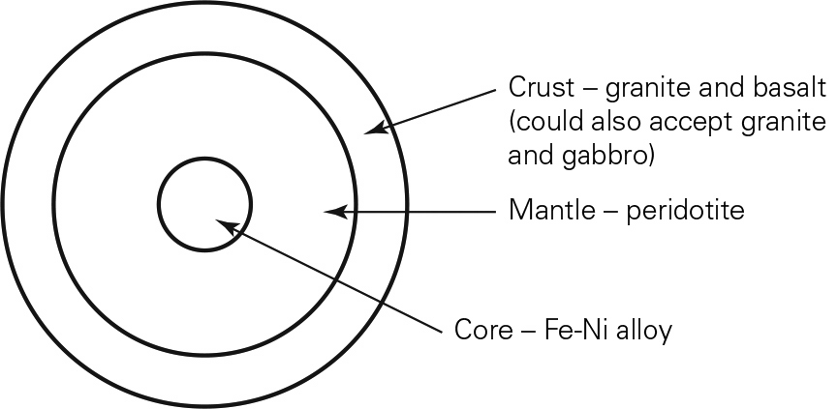

DIF: Difficult REF: 1.5
OBJ: 1G. Distinguish the internal layers (crust, mantle, and core) of the Earth.
MSC: Applying

8. How do we know that the density of the Earth’s interior is much greater than common rocks on the Earth’s surface?

ANS:
We can calculate the average density for the Earth as a whole by using its gravitational pull and volume. This density is greater than the density measured for the common rocks on the Earth’s surface. To achieve this average density, rocks in the interior must contain denser material than the Earth’s surface rocks.

DIF: Medium REF: 1.7
OBJ: 1G. Distinguish the internal layers (crust, mantle, and core) of the Earth.
MSC: Analyzing

9. What distinguishes the concepts “crust and mantle” from “lithosphere and asthenosphere”?

ANS:
Crust and mantle are two of three divisions of layering of the Earth; the third is the core. This way of dividing the Earth into layers is based on how seismic waves move through the Earth’s material. Properties of seismic waves such as velocity and refraction exhibit sudden changes at certain depths in the interior. These depths define boundaries between core and mantle, and even between inner and outer core. The lithosphere and asthenosphere are also layers of the Earth, but instead of being based on seismic waves, this division is based on an outer brittle layer versus a lower plastic-like layer. The lithosphere is brittle and the asthenosphere can slowly flow like a plastic. The lithosphere overlaps with the crust and the uppermost part of the upper mantle; the asthenosphere is below this.

DIF: Medium REF: 1.8
OBJ: 1H. Explain the relationship between the lithosphere and the asthenosphere.
MSC: Evaluating

