Chapter 1—Three Old Worlds Create a New, 1492-1600

SHORT ANSWER

Instructions:
• | Identify each item. Give an explanation or description of the item. Answer the questions who, what, where, and when.
• | Explain the historical significance of each item. Establish the historical context in which the item exists. Establish the item as the result of or as the cause of other factors existing in the society under study. Answer this question: What were the political, social, economic, and/or cultural consequences of this item?

1. Alvar Nuñez Cabeza de Vaca

ANS:

2. Paleo-Indians

ANS:

3. Teotihuacán

ANS:

4. the Mayas

ANS:

5. the Pueblos

ANS:

6. the Mississippians

ANS:

7. the City of the Sun (Cahokia)

ANS:

8. Monks Mound

ANS:

9. The Aztecs

ANS:

10. Huitzilopochtli

ANS:

11. Tenochtilán

ANS:

12. sexual division of labor

ANS:

13. Upper Guinea

ANS:

14. Lower Guinea

ANS:

15. dual-sex principle

ANS:

16. the Sandé and Poro cults

ANS:

17. the Black Death

ANS:

18. the Hundred Years' War

ANS:

19. the lateen sail, the compass, the astrolabe, and the quadrant

ANS:

20. Ferdinand of Aragon and Isabella of Castile

ANS:

21. movable type and the printing press

ANS:

22. Travels by Marco Polo

ANS:

23. the Mediterranean Atlantic

ANS:

24. the Azores, the Madeiras, and the Canaries

ANS:

25. the Northeast Trades and the Westerlies

ANS:

26. Prince Henry the Navigator

ANS:

27. São Tomé

ANS:

28. Christopher Columbus

ANS:

29. Amerigo Vespucci

ANS:

30. Leif Ericsson

ANS:

31. John Cabot

ANS:

32. Hernán Cortés

ANS:

33. Malinche

ANS:

34. the Spanish model of colonization

ANS:

35. the encomienda system

ANS:

36. Spanish missionaries

ANS:

37. the Columbian exchange

ANS:

38. smallpox

ANS:

39. syphilis

ANS:

40. sugar, the horse, and tobacco

ANS:

41. maize

ANS:

42. John Hawkins and Sir Francis Drake

ANS:

43. Richard Hakluyt

ANS:

44. Sir Walter Raleigh

ANS:

45. Roanoke

ANS:

46. A Briefe and True Report of the New Found Land of Virginia

ANS:

MULTIPLE CHOICE

1. Which of the following were the first to cultivate food crops in the Americas?
a. | European colonists in South America
b. | Indians along the Atlantic seaboard of North America
c. | Jesuit missionaries in southern California
d. | Indians living in central Mexico

ANS: D

2. Which of the following was a consequence of the spread of agricultural techniques among Indian groups?
a. | Cultural differences among groups of Indians disappeared.
b. | Most groups began to live a more sedentary existence.
c. | The various groups began to engage in almost constant warfare.
d. | Political power within the various groups fell into the hands of land-owning elite.

ANS: B

3. Why did the practice of settled agriculture lead to the emergence of more complex civilizations?
a. | People practicing settled agriculture needed a more structured political system.
b. | People with a steady supply of food were free to devote their energy to accumulating wealth, producing art, and creating ceremonies and rituals.
c. | An increase in the number of children in such societies gave rise to the educational institutions associated with complex civilizations.
d. | Property owners in such societies demanded laws and institutions that protected their property rights.

ANS: B

4. What did the city-states of Mesoamerica and the urban clusters known as the Mississippian culture have in common?
a. | Each practiced a form of township democracy.
b. | Each was engaged in extensive trade in the Caribbean basin.
c. | Each had religious beliefs that were monotheistic.
d. | Each reached the height of its power only after achieving success in agriculture.

ANS: D

5. Which of the following best explains the differences in the means of subsistence and lifestyles that emerged among Indian groups in the New World?
a. | Disagreements over political beliefs caused groups to separate.
b. | The various tribes migrated to the Americas separately and came from widely divergent cultures.
c. | Different Indian groups adapted their means of subsistence and lifestyles to the environment in which they settled.
d. | Geographic barriers in the New World made interaction between different Indian tribes impossible.

ANS: C

6. Which of the following best explains the fact that bands of Indian hunters remained small in the area of the Great Basin (present-day Nevada and Utah)?
a. | The disease environment dramatically lowered the life expectancy of the inhabitants of the Great Basin.
b. | The tribes of the Great Basin enacted laws that imposed strict limitations on the size of each band within the tribe.
c. | The inadequate supply of large game made it difficult to find food in sufficient quantity to support large groups.
d. | The practice of human sacrifice significantly reduced the population of the bands and tribes of the Great Basin.

ANS: C

7. North American Indian agricultural societies were alike in which of the following respects?
a. | They all defined the extended family matrilineally.
b. | The clans that made up these societies were defined patrilineally.
c. | They all allocated agricultural chores to women.
d. | Women were allowed to be chiefs in all these societies.

ANS: A

8. The design of pre-Columbian Indian villages indicates which of the following?
a. | These societies had an extensive trade network with one another.
b. | Native Americans once had a common culture because there are no differences among the villages of hunter-gatherer societies, agricultural societies, and fishing societies.
c. | The design of Indian villages around a central place of worship indicates that, although widely separated, all Indians had the same religious beliefs.
d. | The defensive design of villages indicates that North American Indians fought with each other long before the arrival of Europeans.

ANS: D

9. Women were most likely to hold political positions in
a. | hunting tribes.
b. | tribes that had no sexual division of labor.
c. | nomadic tribes.
d. | agricultural tribes.

ANS: D

10. Which of the following is true of the Algonquians?
a. | They followed the example of the Aztecs, practicing settled agriculture and living a sedentary existence.
b. | They accepted women as rulers in some villages.
c. | They defined the extended family patrilineally.
d. | They were unique among the North American tribes in that they had no known religious beliefs.

ANS: B

11. When Europeans began to colonize North America, the Indians on the continent
a. | did not see themselves as one people and did not think of uniting against the invaders.
b. | realized that unity against the invaders was essential to survival.
c. | quickly accepted the religious ideas expressed by European missionaries.
d. | recognized the importance of accepting and adopting the major characteristics of European culture.

ANS: A

12. Which of the following was one of the major means of subsistence of the people living in the northernmost region of Upper Guinea?
a. | Farming
b. | Animal husbandry
c. | Cultivation of rice
d. | The gold trade

ANS: C

13. In the fifteenth century, Lower Guinea and Upper Guinea differed in which of the following respects?
a. | The governments of Lower Guinea were democratic; those of Upper Guinea were autocratic.
b. | Women were responsible for the cultivation of rice in Lower Guinea but were the primary local traders in Upper Guinea.
c. | The peoples of Lower Guinea continued to practice traditional African religions; those of Upper Guinea were heavily influenced by the Islamic religion.
d. | Women were denied political power in Lower Guinea but held powerful political and religious positions in Upper Guinea.

ANS: C

14. Most Africans of Lower Guinea were similar to the agricultural Indians of the Americas in which of the following respects?
a. | The political systems of both consisted of hereditary rulers governing agricultural empires.
b. | Both assigned agricultural tasks to men.
c. | Both lived a nomadic existence.
d. | The religious practices of both revolved around rituals designed to ensure a good harvest.

ANS: D

15. At the time of initial contact with the Europeans, Lower Guinea was characterized by
a. | powerful and wealthy empires.
b. | decentralized political and social authority.
c. | religious disagreements between Christian rulers and the Muslim masses.
d. | acceptance of and strong devotion to Islam on the part of rulers and people.

ANS: B

16. The societies of West Africa were like Native American societies in which of the following respects?
a. | The social systems of both were organized on the basis of the dual-sex principle.
b. | The political systems of both were organized on the basis of autocratic rule.
c. | In both, work assignments were organized on the basis of a sexual division of labor.
d. | In both, women were allowed to hold formal political power over men.

ANS: C

17. The social systems of West Africa were all organized on the basis of the dual-sex principle, which meant that
a. | female political and religious leaders governed the women and males ruled the men.
b. | men and women were expected to have not only a sexual partner of the opposite sex but one of the same sex as well.
c. | every man could have two wives and every woman could have two husbands.
d. | all individuals were believed to have both a masculine and a feminine side.

ANS: A

18. Members of the Sandé cult
a. | frequently engaged in wars with neighboring tribes to obtain prisoners for human sacrifice to the gods.
b. | established diplomatic relations between Benin and Portugal and acted as middlemen in the trade between the two societies.
c. | were led by female religious leaders and were not allowed to reveal the secrets of their cult to men.
d. | were the only known West Africans to have monotheistic religious beliefs.

ANS: C

19. Fifteenth-century European, African, and Mesoamerican societies differed from most North American Indian societies in that the former were
a. | theocratic in nature.
b. | hierarchical in nature.
c. | egalitarian in nature.
d. | patriarchal in nature.

ANS: B

20. In contrast to African and Native American societies, women in European societies were
a. | not allowed to engage in certain kinds of work.
b. | usually denied positions of political and religious authority.
c. | primarily responsible for discipline within the family.
d. | equal to men in the eyes of the law.

ANS: B

21. As a result of the Black Death,
a. | the people of Europe turned to the Christian religion for the first time.
b. | it is estimated that one-third of the people of Europe died in the late fourteenth century.
c. | the Angle and Saxon tribes of England were so weakened that they were easily defeated by William of Normandy.
d. | European scientists finally accepted the germ theory of disease long advanced by Arab scholars.

ANS: B

22. After the Hundred Years' War, the monarchs of England and France worked to consolidate their political power. They were aided in this effort by
a. | their acceptance of the concept of constitutional monarchy.
b. | a new sense of national identity among their subjects.
c. | a resurgence of regional loyalties among nobles.
d. | promising their subjects that they would uphold the concept of human rights.

ANS: B

23. Marco Polo's Travels was important primarily because it convinced many Europeans
a. | of the need for a defensive alliance against hostile non-European powers.
b. | that direct trade by sea with China was possible.
c. | of the need to Christianize China.
d. | that Chinese culture was superior to European culture.

ANS: B

24. The primary motive for the fifteenth- and sixteenth-century European voyages of exploration and discovery was the desire to
a. | spread Christianity around the world.
b. | verify the new scholarly theory that there were undiscovered continents.
c. | gain direct access to the goods of Africa and Asia.
d. | establish naval control of the seas.

ANS: C

25. These winds made it easy for Spanish and Portuguese mariners to sail from the Iberian Peninsula to the Canary Islands.
a. | The Northeast Trades
b. | The Polar Easterlies
c. | The Horse Latitudes
d. | The prevailing Westerlies

ANS: A

26. Why was it difficult for Spanish and Portuguese mariners to return home from the Canary Islands?
a. | The Northeast Trades, which quickly carried Iberian sailors from the Iberian peninsula to the Canaries, blow steadily southward.
b. | Unusual magnetic fields in that area rendered navigational instruments useless.
c. | Berber pirates preyed on ships sailing northward from the Canaries.
d. | They had no knowledge of the tacking maneuver.

ANS: A

27. The Mediterranean Atlantic prepared the way for the European voyages of exploration and discovery because it was there that European mariners
a. | first learned the skill of trimming their sails.
b. | discovered that the Westerlies would carry them swiftly into the Atlantic and toward the Caribbean.
c. | first learned the importance of square sails in making their ships more maneuverable.
d. | learned the valuable strategy of sailing around the wind.

ANS: D

28. By the 1470s the world's first colonial plantation economy was found in the
a. | Azores.
b. | Canaries.
c. | Madeiras.
d. | West Indies.

ANS: C

29. After conquering the last Canary Island in 1496, the Spanish devoted the land to the cultivation of
a. | corn.
b. | rice.
c. | sugar.
d. | tobacco.

ANS: C

30. Which of the following correctly characterizes the trade relationship between Portugal and the states of West Africa?
a. | The Portuguese merchants grew wealthy; the African chiefdoms gained little.
b. | The African chiefdoms gained wealth and power; the Portuguese gained little.
c. | The Portuguese merchants controlled the terms and conditions of the trade.
d. | The rulers of West Africa controlled the terms and conditions of the trade.

ANS: D

31. Black slavery was introduced into Europe by the
a. | French.
b. | Spanish.
c. | English.
d. | Portuguese.

ANS: D

32. The first economy based primarily on the bondage of black Africans was created in
a. | the Azores.
b. | the Canaries.
c. | the Madeiras.
d. | São Tomé.

ANS: D

33. Based on their experiences in the islands of the Mediterranean Atlantic, the Europeans learned that they
a. | would have to use European laborers if colonies were to be productive and profitable.
b. | could successfully transplant their crops and livestock to exotic locations.
c. | would never be able to develop a system for supplying workers to distant colonies.
d. | could successfully cure the diseases they contracted in distant lands.

ANS: B

34. As a result of his visit to the Portuguese colony on the Gold Coast of Africa, Columbus
a. | began to understand how important rice cultivation could be in solving food shortages in his native Genoa.
b. | recognized the economic potential of the slave trade.
c. | acquired a hatred for abusive and exploitive labor systems.
d. | learned how important it was to understand and accept the belief systems of non-Europeans.

ANS: B

35. Queen Isabella decided to finance exploratory voyages, in part, because she
a. | believed it would divert her subjects' attention away from Spain's domestic problems.
b. | hoped profits from such voyages would help finance an expedition to wrest Jerusalem from the Muslims.
c. | wanted to prevent England from colonizing Africa.
d. | wanted knowledge about other world cultures.

ANS: B

36. Columbus's log of his first encounter with the New World and its inhabitants reveals which of the following?
a. | He wanted to profit from the land he had found by exploiting its natural resources, including its people.
b. | He wanted to exterminate all Native Americans and completely destroy the cultures they had built.
c. | He insisted that Europeans had come merely to observe, not to change, the cultures of the New World's native inhabitants.
d. | He believed that his primary goal should be to Christianize the native inhabitants of the land he had found.

ANS: A

37. The first person to publish the idea that Columbus had discovered a new continent was
a. | Pedro Alvares Cabral.
b. | John Cabot.
c. | Amerigo Vespucci.
d. | Martin Waldseemüller.

ANS: C

38. Which of the following is true of John Cabot?
a. | He brought back to Europe the first formal knowledge of North America's northern coastline.
b. | He is credited with having found an all-water route through North America to Asia.
c. | As a result of his voyages, Cabot was the first European to realize that Columbus had not reached Asia.
d. | He established a settlement at Vinland, which was the first European settlement in North America.

ANS: A

39. Under the encomienda system,
a. | the Catholic Church established schools and hospitals in Indian villages.
b. | individual conquistadors were granted tributary Indian villages from which they could collect money and goods.
c. | Spanish Jesuits undertook the task of converting Indians to the Christian faith.
d. | prisoners from Spain were sent to work in New World silver mines for periods ranging from seven years to life.

ANS: B

40. Large numbers of Native Americans living in Spanish territory accepted Catholicism, in part, because
a. | it was the religion of their conquerors.
b. | they believed the parish priests could cure them of European diseases.
c. | they believed they would be executed if they refused.
d. | Catholicism seemed to promise immediate rewards in this life.

ANS: A

41. Which of the following was a long-term consequence of the influx of gold and silver from the New World into Spain?
a. | The Spanish government funded domestic social programs that substantially raised the standard of living of the peasant masses.
b. | Rapid inflation led to an unfavorable balance of trade and the collapse of many businesses.
c. | The ready availability of investment capital at low interest rates led to the expansion and modernization of Spanish industries.
d. | The Spanish government became complacent and failed to defend the nation's interests against the aggressive Dutch and English.

ANS: B

42. The main reason for the dramatic decline of the Indian population of Hispaniola from 1492 to 1542 was the
a. | Spanish decision forcibly to move the Indians to South America.
b. | inhumanity of the Spanish slave system.
c. | introduction of European diseases onto the island.
d. | psychological devastation caused by systematic destruction of traditional Indian culture.

ANS: C

43. The Lakota, Comanches, and Crows of the Great Plains were profoundly affected by the
a. | introduction of the horse into North America.
b. | introduction of wheat and rye into North America.
c. | cultivation of tobacco.
d. | introduction of settled agriculture into North America.

ANS: A

44. The permanent outposts established by Europeans in North America in the early seventeenth century were initially inhabited by people whose aim was to
a. | establish permanent colonies for their respective countries.
b. | establish military bases for their respective countries.
c. | Christianize the Indians of North America.
d. | make money by sending as many beaver pelts as possible home to Europe.

ANS: D

45. Which of the following is true concerning trade between Indians and Europeans?
a. | Such trade was beneficial only to Europeans.
b. | In order to supply Europeans with much-demanded furs, some Indian bands abandoned their traditional economies.
c. | The controls imposed by some Indians on trade with Europeans created financial problems for European trading companies.
d. | Most Indian bands traded with Europeans only out of fear of reprisals if they refused.

ANS: B

46. Who published translations of stories of exploratory voyages and argued in favor of English colonization of North America?
a. | John Cabot
b. | Richard Hakluyt
c. | John Hawkins
d. | Captain John Smith

ANS: B

47. Sir Walter Raleigh attempted to establish English outposts in the New World, in part, because he wanted to
a. | establish tobacco plantations.
b. | serve the colonies of other European nations by carrying New World products into European markets.
c. | establish a haven for religious dissenters.
d. | establish trade with the Indians.

ANS: D

ESSAY

1. Discuss the series of Mesoamerican civilizations that eventually gave rise to the Aztec civilization, and describe the major characteristics of Aztec culture. How did the Indian cultures that emerged in Mesoamerica differ from those that emerged in North America? What factors caused these differences?

ANS:

2. Discuss the similarities and differences among the Indian cultures of North America at the beginning of the seventeenth century. How can the differences among these cultures be explained?

ANS:

3. Discuss the similarities and differences among the fifteenth- and sixteenth-century West African cultures. How can the differences among these cultures be explained?

ANS:

4. Discuss the political, social, and economic characteristics of the Algonquian, Iroquoian, and Muskogean Indians in the early seventeenth century.

ANS:

5. Discuss the similarities and differences concerning the sexual division of labor among the English, the Iroquois, and the societies of West Africa.

ANS:

6. Discuss the prevailing winds of the North and South Atlantic as both a hindrance and an aid to European seafarers, and examine the role these winds played in the European voyages of exploration and discovery.

ANS:

7. List and discuss the three key lessons of colonization learned by Europeans from their experiences in the islands of the Mediterranean Atlantic and the African coast.

ANS:

8. Discuss the impact of the transfer of plants, diseases, and animals on Europe and Africa and on the Americas.

ANS:

9. Discuss the goals behind Spanish colonization of the Americas, and examine the features of the Spanish model of colonization. Did Spain attain its goals? What impact did Spanish colonization have on Spanish society and on the civilizations that the Spanish encountered in the Americas?

ANS:

10. Discuss the first English attempt to plant a permanent settlement in North America, and explain why that attempt failed.

ANS:

MAP EXERCISES

Map Exercise 1-1
Use the map that follows:

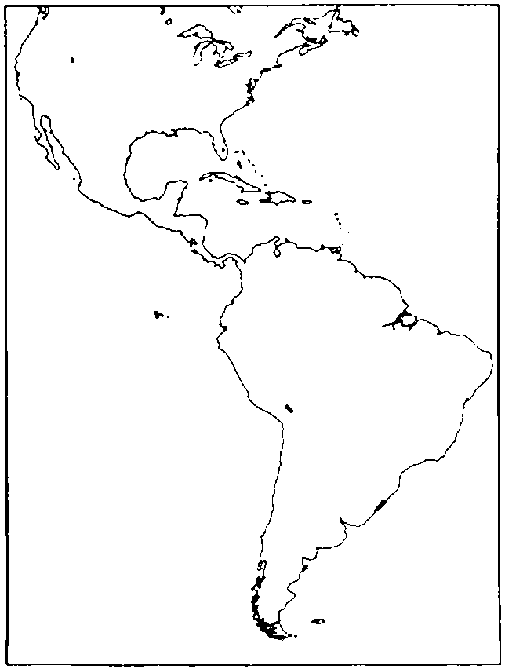

1. Refer to Map Exercise 1-1. On the outline map of the Americas above and referring to an historical atlas, draw in the boundaries for and mark the location of each of the present-day nations:
Argentina | Ecuador | Paraguay
Belize | French Guiana | Peru
Bolivia | Guatemala | Puerto Rico
Brazil | Guyana | Surinam
Chile | Haiti | United States
Colombia | Honduras | Uruguay
Costa Rica | Jamaica | Venezuela
Cuba | Mexico
Dominican Republic | Nicaragua
El Salvador | Panama

2. Refer to Map Exercise 1-1. Mark the location of each of the following cities:
Buenos Aires
Caracas
Lima
Mexico City
Panama
Santiago

3. Refer to Map Exercise 1-1. Using three pens of different colors (highlight pens will work fine) and referring to an historical atlas, mark the location of:
the Aztec Empire
the Inca Empire
the Maya Empire

4. Refer to Map Exercise 1-1. Referring to an historical atlas, mark the following:
the route taken by Cortés in his conquest of the Aztec Empire
the route taken by Pizarro in his conquest of the Inca Empire

Map Exercise 1-2
On the outline map of the world that follows and using the text as a reference, mark the following:

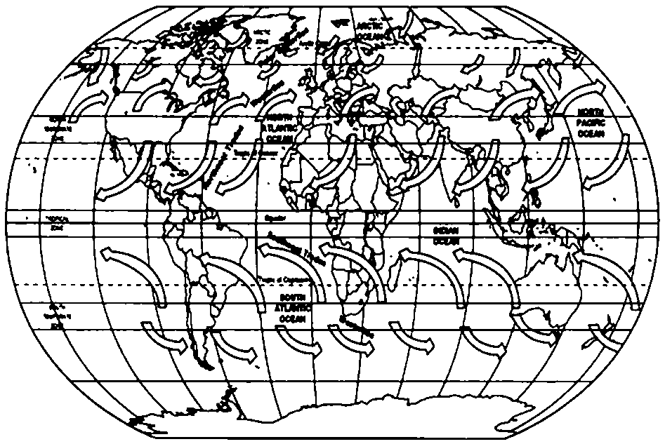

5. Refer to Map Exercise 1-2.

Part 1
You will need five colors to complete this map exercise. (Highlight pens will work fine.)

Trade winds (Northeast and Southeast) blow from the Horse Latitudes toward the Equator. The rotation of Earth causes these winds to blow diagonally rather than directly North or South.

Westerlies blow from the Horse Latitudes toward the polar regions. The diagonal deflection of these winds is also caused by Earth's rotation.

Stagnant air exists in the Horse Latitudes and in the area called the Doldrums. (The Horse Latitudes are so named because the Spanish, who frequently ferried horses across the Atlantic, often found their sailing vessels stalled in this region. As a result, they ran out of water for the horses. As the horses died from thirst, they had to be thrown overboard.)

Polar Easterlies blow from the Arctic regions toward the more temperate regions to the South.

Use one color to highlight the area in which the Doldrums are located. Label this area "The Doldrums." (The Doldrums are located to the immediate north and south of the Equator, where the Northeast Trades and the Southeast Trades meet.)

Use a second color to highlight the Trade winds, both Northeast and Southeast.

Use a third color to highlight the areas in which the Horse Latitudes are located. Label this area "The Horse Latitudes." (The Horse Latitudes are located about at about 30 degrees North latitude⎯in the area between the Westerlies and the Northeast Trades⎯and at about 35 degrees South latitude (in the area between the Southeast Trades and the Westerlies).)

Use a fourth color to highlight the Westerlies.

Use a fifth color to highlight the Polar Easterlies.

Part 2
On the outline map of the world above and using the text as a reference, mark the following:

• | The route of Columbus's first voyage to the New World.
• | The route of Cabot's 1497 voyage to the New World.
• | The route of Cabot's 1498 voyage to the New World.

Part 3
Based on this map exercise, and using your text as a reference, answer the following questions:

1. | What winds aided Columbus in his voyage from Spain to the New World?
2. | What winds appear to have hindered Cabot on his first voyage from England to the New World?
3. | What winds appear to have made Cabot's second voyage easier?

ANS:

